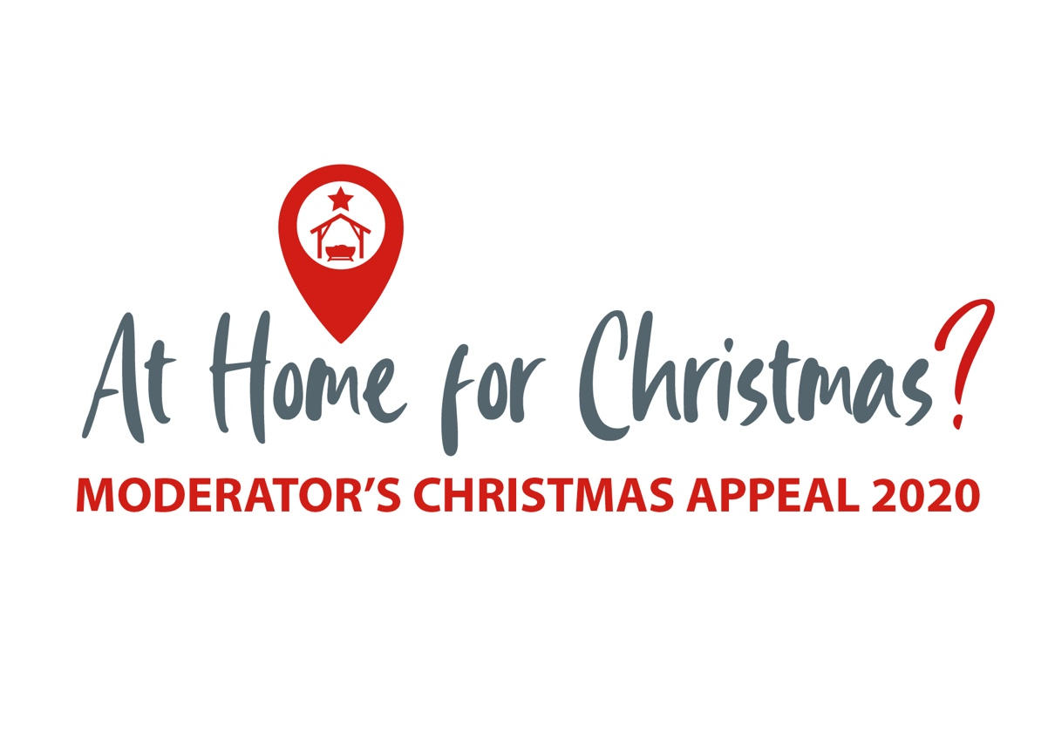

**Background Information  
– South Sudan**

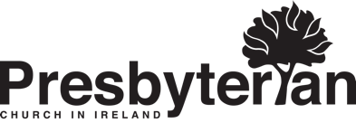



**Background Information – South Sudan**

The Moderator’s Christmas Appeal is, in the broadest sense, a response to the Covid-19 global pandemic considering the impact of the same on global healthcare systems, on the socio-economic context of the world’s poorest people, and on displaced people and refugees.

The country of South Sudan very quickly stood out as a country whose story could be shared through the Appeal in this context. South Sudan, home to more than 12 million people, is the world’s youngest nation having gained independence in 2011, drawing an end to Africa’s longest running civil war. However, this peace was short lived when in December 2013 civil war broke out again in South Sudan along ethnic and political lines, driving 3.9 million people from their homes and putting more than 6 million people in emergency or crisis levels of food insecurity. 2017 saw a further decline with ongoing fighting and economic collapse and although a peace deal holds at present the situation is precarious.

South Sudan has been impacted by five intersectional crises – Covid-19, conflict, severe food insecurity, locusts, and most recently, devastating floods. It ranks third among the countries most vulnerable to the impacts of Covid-19 and has the second highest number of people facing food crisis, with half the population food insecure, nearly 300,000 children with severe acute malnutrition, and the potential for famine in several regions. Covid-19 has also decimated supply chains leading to escalating prices for staple foods and basic commodities. Add to this the challenges of 1.6 million people internally displaced and of reaching the 7.5 million people in need of humanitarian assistance under some of the greatest obstacles impeding humanitarian access to vulnerable populations.

The recent floods, the worst in sixty years, have destroyed food crops and livestock and have swept away homes, water points, sanitation facilities, and school shelters leading to the displacement of a further 700,000 vulnerable people. And ongoing conflict and inter-communal violence have, alongside Covid restrictions, hampered aid efforts. The intersectionality of these crises means that each new crisis event has a tragic and disproportionate effect on already vulnerable people now finding themselves living in a Covid landscape. __________________________________________

Monies raised through the Moderator’s Christmas Appeal will be supporting projects administered by our relief and development partners, Christian Aid and Tearfund, and PCI partner churches, in South Sudan and elsewhere. Here are just some examples.

**Christian Aid**

* Christian Aid will be supporting the work of partner organisation Christian Action for Relief and Development (CARD), the development wing of the Episcopal Church of South Sudan. The focus of this work is to increase access to safe, clean water and contribute to the improvement of hygiene and sanitation to help control the spread of Covid-19 in the western state of Bahr El Ghazal.

CARD will work in community settings like churches, marketplaces, prisons, and schools to create awareness and provide suitable hand washing facilities to prevent Covid-19 transmission and infections. Hygiene promoters will also be trained to encourage good hand hygiene practices. School hygiene clubs will be developed to ensure that children, PTAs, and teachers are educated about Covid-19. This element of the project will also work to repair and restore existing WASH facilities in schools, or to provide new and additional hand-washing stations and soap to schools as necessary.

* The Moderator’s Christmas Appeal will also be supporting Christian Aid’s work with the Karen Baptist Convention’s Christian Social Services Development Department (CSSDD) in Kayin State, Myanmar. Here people traditionally rely on agriculture and animal husbandry for their livelihoods and are acutely vulnerable during times of crisis such as Covid-19. The project here will seek to reduce the vulnerability of families through a resilient livelihoods approach including training in ‘climate smart’ agriculture and livestock practices, training for market and business development committees, expanding a network of Disaster Management Committees, and providing livelihood grants to support the implementation of capacity building activities in marginalised households.

**Tearfund**

* Through their partner ALARM (African Leadership and Reconciliation Ministries) Tearfund will be supporting security agencies, enforcing the government restrictions, in displaying key health messaging around Covid-19. Members of the organised forces will receive training on Covid-19 prevention measures and be provided with PPE. A series of radio talk shows will provide an awareness campaign on Covid-19 and hand washing facilities will be procured and distributed to communities alongside a round of door-to-door support about the proper use of hand-washing facilities.
* The Moderator’s Christmas Appeal will also provide for ongoing support in the challenging context of the Eastern Democratic Republic of Congo now further challenged in the light Covid-19. Tearfund partner, Action Entraide, will be teaching Conservation Agriculture and offering vocational and life skills training in Ituri province to support food and livelihood security and stimulate the local economy. And in Beni Territory, Tearfund partner, Mavuno, will be working with churches in the area to select vulnerable households to receive training and agricultural inputs enabling them to create a resilient source of income and access other healthcare and education services.

**PCI Partners**

Funds raised through the Appeal will also be channelled to PCI’s partner church the Presbyterian Church of South Sudan whose Presbyterian Relief and Development Agency is active across a range of areas including health, water and sanitation, agriculture and food security, education and livelihoods, and psychosocial support. The Moderator’s Christmas Appeal will also support healthcare services in Nepal through United Mission to Nepal, in Livingstonia Synod, Malawi (Church of Central Africa Presbyterian) and in Sumba, Indonesia through the Christian Church in Sumba (Gereja Kristen Sumba). And frontline healthcare staff in the Diakonia Programme (Hungarian Reformed Church) in Romania will be supported in their work in residential care homes and in providing palliative care. The diaconal arm of National Evangelical Synod of Syria and Lebanon, the Compassion Protestant Society, will also be supported in its work with vulnerable communities, both Lebanese and the 1.1 million Syrians in refugee camps around the country. They are operating two Covid-19 projects, one focusing on food security and the other on provision of hygiene kits for families in refugee camps.