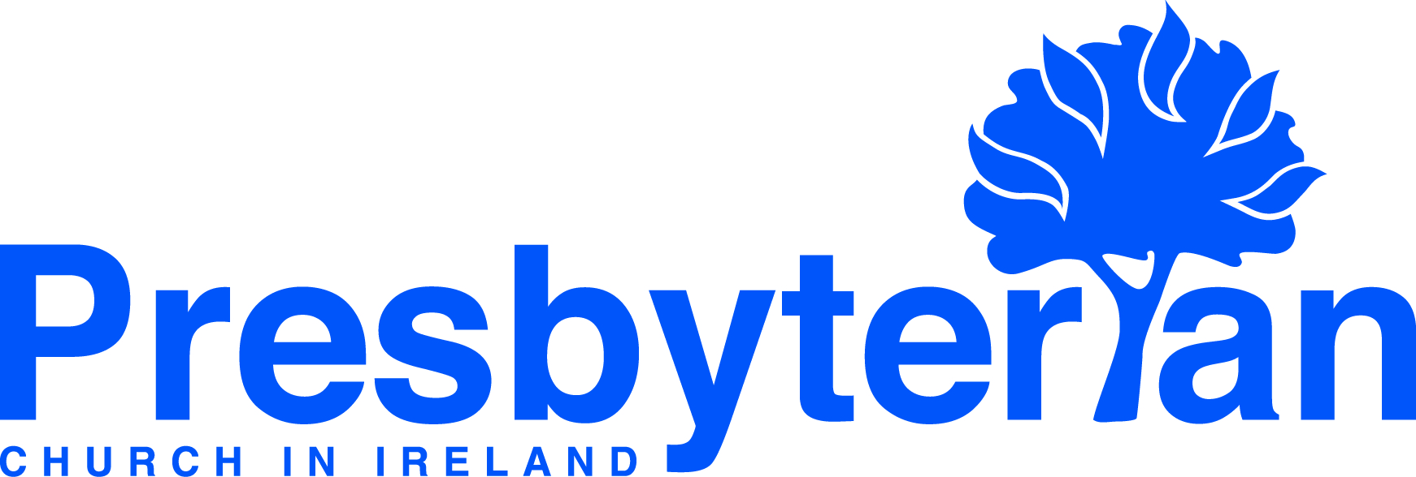
Let’s Pray | Sun 31 March - Sat 6 April 2024
Friday 5 April
- Thompson House | Give thanks for 40 years work and witness in Thompson House, our Church’s supported housing scheme
for offenders. Pray for the staff as they come alongside residents & show them Christ’s love by simply showing that they care.
- Human Dignity | Give thanks for John Mullen, convener of the Human Dignity Panel. Pray for the panel members, that they
would have the discernment and wisdom necessary to articulate the views of PCI on complex issues such as assisted suicide
and euthanasia in the Public Square.
Thursday 4 April
      - David Hagan, healthcare chaplain | Give thanks for opportunities David has to listen to, chat with, read and pray with patients, families and staff. Give thanks for the team of chaplains who work together so well. Pray that they will sensitively share the love, hope and grace of God.
      - Clones, Stonebridge, Ballyhobridge and Newbliss | Give thanks for a new kitchen and toilet extension to Clones Presbyterian Church, pray that it may enhance opportunities for both the Presbyterian and Brazilian congregations. Pray for preparations for an evangelistic harvest mission in the Clones Group from 6 – 13 October.
Wednesday 3 April
- Steve and Rosie Kennedy, global mission workers, Romania | Give thanks for the ministry opportunities Steve and Rosie have had in recent weeks. Pray that as a family they would know God’s guidance and encouragement as they look to the future and prepare to transition to their next chapter of ministry.
- Presbyterian Church of East Africa (PCEA) | Pray for the PCEA leadership as they make preparations for the 24th General Assembly to be held from 8 – 13 April, 2024 at St Andrew’s Church, Nairobi, and especially for the Moderator of the 24th General Assembly, Rt Rev Thegu Mutahi, the Honorary Treasurer, Elder David Ndumo, and the Deputy Secretary General, Rev John Mbae, who will be installed into their offices at the Assembly.
Tuesday 2 April
- Bray & Blackrock | Give thanks to God for all his goodness and faithfulness to the congregations. Pray that God would continue to grow their love for him and each other, and that he would help them as they seek to share Jesus with others.
- Heather Anthony, community outreach worker | Pray for Heather as she serves the congregation of First Ballynahinch Presbyterian and the local community, that those she meets would know the love and hope of Christ in their lives.
Monday 1 April
- Stephen and Angelina Cowan, global mission workers, Kenya | Give thanks for all those who have faithfully contributed over the years in support of student fees. Give thanks also for the adults in Tuum who are learning to read through the iteach literacy and knowledge app. Pray that the vision and potential of this app project would be recognised and well supported.
- Hungarian Reformed Church (HRC) | Pray for the leadership and members of the Transcarpathian (Western Ukraine) Church District of the Hungarian Reformed Church, that they would persevere in the face of growing difficulties, trusting in God’s provision and protection.
Saturday 6 April
- General Council | Pray for the United Appeal Committee as they meet with representatives of the General Assembly
Councils to begin the process of drawing together the recommendations for the 2025 United Appeal which will be brought before this year’s General Assembly.
- Training in Ministry | Rev Dr Mark Pickles (Vicar of St Andrew’s Cheadle Hulme, Stockport) is spending time in Union
College as Visiting Scholar. Give thanks for Mark’s willingness to share in Union, and ask the Lord to use him as he teaches ministry students, licentiates and others.
Sunday 31 March
- Moderator | “Why do you look for the living among the dead? He is not here he has risen.” Luke 24:5-6. Pray that we might grasp afresh the wisdom of the Bible, that when death has been taken care of then we can live life with
confidence. We rejoice in the resurrection of Jesus, every day.
- Worship: Easter Sunday | Ask that God would enable us to experience afresh as we worship the wonder of his love for us
in Jesus and the resurrection power that makes us more than conquerors over all that stands against us in our lives.

