GROWING IN FRUITFULNESS
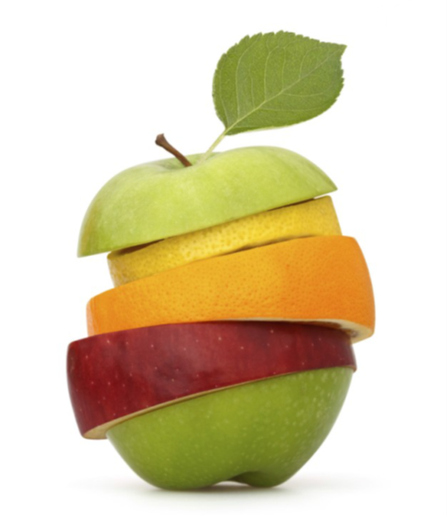
RIPENING: TOWARDS IDENTIFYING TWO AREAS
IN WHICH YOUR CONGREGATION WANTS TO PRIORITISE GROWTH
I. CORINTHIANS 3v.1-9

3 Brothers and sisters, I could not address you as people who live by the Spirit but as people who are still worldly – mere infants in Christ. ² I gave you milk, not solid food, for you were not yet ready for it. Indeed, you are still not ready. ³ You are still worldly. For since there is jealousy and quarrelling among you, are you not worldly? Are you not acting like mere humans? ⁴ For when one says, ‘I follow Paul,’ and another, ‘I follow Apollos,’ are you not mere human beings?

⁵ What, after all, is Apollos? And what is Paul? Only servants, through whom you came to believe – as the Lord has assigned to each his task. ⁶ I planted the seed, Apollos watered it, but God has been making it grow. ⁷ So neither the one who plants nor the one who waters is anything, but only God, who makes things grow. ⁸ The one who plants and the one who waters have one purpose, and they will each be rewarded according to their own labour. ⁹ For we are fellow workers in God’s service; you are God’s field, God’s building.

Discuss: What do you see as the challenge & opportunity of widening the decision making about which two areas of your congregation’s life and witness to prioritise?

The Fruitful Congregation Prayer

Discuss: How might you use the Fruitful Congregation Prayer?

Revisiting where we are

Season 1 SEEDING: Introduce God’s vision of fruitfulness to your members
- Web-based, flexible launch resource and material for 6 follow up sessions

Season 2 RIPENING: Identify two areas in which your congregation discern God wants you to prioritise developing growth in the next season of life and witness
- Web-based, flexible launch resource (Sermon or Bible Study material)
- A range of options and tools to enable your congregation to choose two areas in which to work for use in Kirk Sessions, working groups or whole congregation setting

Season 3 HARVESTING: Implement the development of habits and ways of doing things which, under God, work the ground and sow the seed for a local expression of fruitfulness
- Signposting resources, stories and ideas

In every season WATERING: Interceding in prayer
- Fruitful Congregations Prayer Journey (Season 1)
- Fruitful Congregation Prayer (Season 2)

Ripening the conversation: Season 2 Flexible Launch Material

- Together for Fruitfulness material from I. Corinthians 3 v.1-9 and accompanying powerpoint. Usable as a sermon outline, Midweek talk, Home Bible Study.
- The Fruitful Congregation Prayer
- Options and tools for framing a conversation in your congregation that will move towards identifying two areas in which you discern God wants you to prioritise developing growth in the next season of life and witness.

Familiarise yourself with all the downloads Season Two of Growing in Fruitfulness available at https://www.presbyterianireland.org/fruitfulcongregations

Options for ripening the conversation: Identifying priority areas - choosing a way of working for your congregation

Three different ways of identifying two areas in which your congregation discern God wants you to prioritise developing growth in the next season of life and witness are offered below. You might want to choose one, mix and match a little, or use all three. Fuller guides explain how to use each option and photocopiable tools required are downloadable. All three options assume the previous use of the Season Two Launch Material in some form to set the scene.

Introducing the fruitful and unfruitful congregation hexagons
Powerpoint and handout

Outlining options and choosing one that fits our congregation

Option 1: Fruit Counter

Best for a congregation:
- that likes a structured, scientific, organised, approach
- that is confident in verbally expressing itself
- that is able to cope with a variety of opinions
- that is secure enough to acknowledge weaknesses
- that is able to see a big picture emerging

Involves a large group discussion, or group discussion, with feedback.

Uses the Fruitful and Unfruitful Congregation hexagon diagrams to invite individual choices. Results in a visual wall display, leading to discussion and capturing ideas for simple next steps on a flipchart.

Option 2: Hanging Fruit

Best for a congregation:
- that is less confident about verbally expressing itself
- that will find a variety of opinions relationally awkward
- that will not easily cope with being confronted with the Unfruitful Congregation analysis
- that is not used to pulling together overall strategy

Involves a group working less verbally and more visually with light facilitation.

Uses the Fruitful Congregation hexagon diagrams displayed on a wall. Post-its allow participants to express their views more individually and privately, but enable the building of an overall picture. Leads to identifying areas of growth, gaps and overlaps in congregational activities. Limited element of discussion. Post-it vote chooses two areas to prioritise and further written contributions suggest a co-ordinated way forward and ideas for simple next steps. This will take more time. It may be best completed over two sessions.

Option 3: Soft Fruit

Best for a congregation:
- that might not be able to gather people together for a larger meeting
- that is less confident about expressing itself
- that has a lot of disjointed organisations and activities
- that will not easily cope with the Unfruitful Congregation analysis
- that is not used to pulling together overall strategy
- that relies on a smaller group to set direction

Involves engaging organisation leaders and using a guiding group to facilitate organisations in telling the story of their work, collecting and evaluating feedback, spotting emerging patterns, identifying two priority areas and simple next steps. Deliverable in two ways as below.

- Gathering of organisation leaders to share their stories of what God is doing
- Visit to organisation leaders to gather their stories of what God is doing

Especially depends upon forming a guiding group that exerts influence by commanding trust and can commend outcomes to gain ownership.

Discuss: Talk about which approach might best fit your congregation.

Towards the tangible fruit of outcomes
After using any of the above approaches, there are a number of crucial key steps.

- Making sense of the conversation and feedback gathered
Some of this will happen in the exercise described above. Nevertheless, it will still be necessary for a group or individual to capture what has been discerned in a short 500 word document. Use short sentences, bullet points etc. for ease of communication.
It should, clearly set out, in your own words, which two areas of congregational life and witness have been identified to prioritise developing growth in the next season of life and witness.

Write down which existing organisations and activities of the congregation will contribute to development, and some suggestions of how. Be careful to include all ages, from children to Senior Citizens. Are there a limited number of achievable, new activities or ways of doing things that will contribute to development?

From these ideas, suggest two or three simple next steps for both priority areas.

- Feel free to contact the Council for Congregational Life and Witness for any help with signposting stories, resources or ideas that might help you move forward in your priority areas

- Communicate widely with the congregation
Ensure there is feedback to the congregation as a whole and any organisation which has been involved in the discernment process. Allow further suggestions to emerge and reshape the finer detail of what has been captured.

Use the widest gathering of members on a Sunday morning to either convey, or distribute feedback and plans for next steps. Think about using a congregational magazine, website, visuals to spread the message in as many ways as possible.

Season 3 HARVESTING: Implement the development of habits and ways of doing things which, under God, work the ground and sow the seed for a local expression of fruitfulness

You are now ready to transition into the third season of Growing in Fruitfulness in which things have to be organised to happen and what you are learning as a congregation carefully and honestly observed and discussed.

- Organise for implementation of the new habits and ways of doing things identified.

Try to involve as many people as you can, in as many ways as you can, so that the widest possible number of the congregation gain some ownership of what is going on and experience to reflect upon.

- Set a date and means to evaluate what you have tried, using the following framework for discussion:-

What have we seen God doing among us? What have we found:-

- Energising (we have seen our expectation of fruitfulness raised by this)
- Surprising (we have seen our expectation of fruitfulness exceed by this)
- Transforming (because of this, we better understand what fruitfulness looks like for us)
- Disconcerting (because of this, we better understand the challenge of being fruitful)
- Yourself having to come to grips with (we have learned this about ourselves as a congregation and are committed to further refining our life and witness to be fruitful)

