Children’s Activity // Mary and Joseph
Animation
Play the short animation that comes with this resource entitled “Mary and Joseph”.
Introduction
Two of the central characters in the Christmas story are Mary and Joseph, Jesus’ earthly parents. They had a pregnancy announced by an angel when they were not yet married and it created some uncertainty and fear initially. However, Mary and Joseph’s faith shone through once they got over the shock!
Mary said, “I am the servant girl of the Lord. Let this happen to me as you say!” (Luke 1:38)
When Joseph woke up, he did what the Lord’s angel had told him to do. Joseph married Mary. (Matthew 1:24)
I am not sure about what Mary was thinking but I can imagine she started to plan the birth of her baby and all that it might entail. What sorts of things do you think Mary might have needed to get for her baby? (e.g. cot, clothes, toys, etc.)
However, there were other plans for the birth of Mary’s son. The ruler of the day, Caesar Augustus decided to call a census (a counting) of all the people. Mary and Joseph had to travel to Bethlehem, a journey of 100 miles from Nazareth, because Joseph was descended from King David. All Mary’s plans were now useless as she would be away from her home when she had her baby. She would be in a strange place without her family or the things familiar to her. Could this really be part of God’s plan?
Bible story
The story can be done in different ways depending on preference and what you have available.
Read from the Bible Luke 2:1-7
Reading or video option Jesus Storybook Bible “He’s Here!”. The videos are available to buy as part of the JSB curriculum or you could search online.
Song suggestion
Hear the bells by Nick and Becky Drake https://www.youtube.com/watch?v=M2EpQQbtbjQ

Activities
Map –
a simple map to show where Mary and Joseph have travelled from, i.e. Nazareth to Bethlehem (100 miles)
Advent wreath
Make an advent wreath that families can hang on their door (maybe the inside in case it gets wet!) and can add to each week.
This week’s activity is to make the wreath and the first of 4 items to add to it.
Below is a link to a template for a wreath that can be printed and cut out on cardboard. Alternatively, the wreath could simply be a ring cut out of card and the elements stuck to it over the weeks.
https://www.pinterest.co.uk/pin/325455510547823679/
The first picture for the wreath is a stable. Mary and Joseph were not at home for Christmas. They travelled to a strange town that was 100 miles from where they lived. They had to stay in a stable.
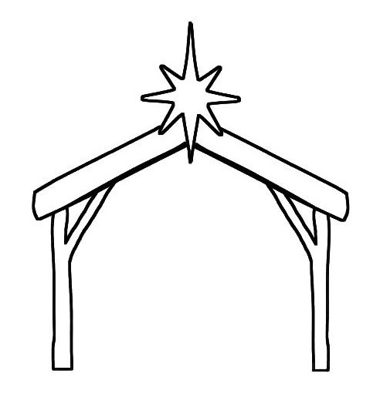
This is the first element of the story that we want to remember of the people involved in the first Christmas who were not at home for Christmas.
Children can simply colour this in, cut it out and then stick it onto their wreath.

