Surveying the landscape of your congregation’s life & witness
Unfruitful - ‘Might we be a bit like that’?

Imagining signs of unfruitfulness

In unfruitful congregations…
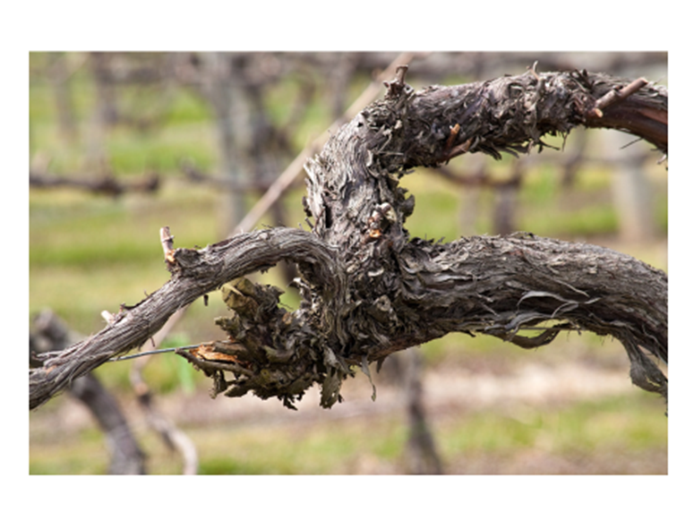
‘Going to church’ is just a weekly routine – IMAGINE: In worship people come, go, stand, sit, close and open their eyes at the right times, but the general sense is there is not a lot of life
Following Jesus in everyday living is seen as an upgrade on church membership – IMAGINE: For most members there is little connection between their church-going life and their Monday to Saturday worlds
‘Church’ is a place where events & programmes happen, but real relationships are shallow – IMAGINE: Church life is busy, the doors are always open, but access to the areas behind the doors of our public lives remain tightly shut
The understanding of the congregation’s purpose is that it is there to meet the preferences of existing members – IMAGINE: The big task in church life is to keep every member provided for and content with what is on offer
Expectation of involvement locally & globally is that we pay and pray for others to ‘go’ & rely on a ‘they’ll come to us’ mind set – IMAGINE: Involvement in overseas mission is arm’s length and formal; Attitude to the local community is, ‘they know where we are if they want us’
Leaders are expected to do all they can, to maintain everything they can, the way it is now – IMAGINE: Leadership meetings revolve around plugging gaps and trying to avoid uncomfortable changes

Discuss the area of greatest unfruitfulness in your congregation’s life & witness.

Ask God to help you find ways to begin to address that weakness.

Surveying the landscape of your congregation’s life & witness
Fruitful - ‘Do we see a bit of that’?

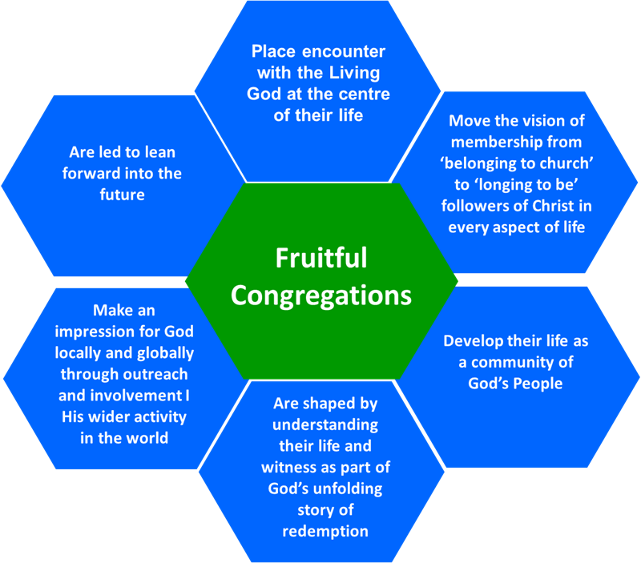

Imagining signs of fruitfulness

Fruitful congregations…

Place encounter with the Living God at the centre of their life – IMAGINE: Members worship and pray with a sense of expectation that God is among them, ready to work in and through their life & witness
Move the vision of membership from ‘belonging to church’ to ‘longing to be’ followers of Christ in every aspect of life – IMAGINE: The way church membership is talked about is that it is expected to equip people of all ages to follow Jesus in all of life’s situations, relationships and circumstances
Develop their life as a community of God’s People – IMAGINE: Time and space is created for members to get to know each other and support one another more deeply
Are shaped by understanding their life & witness as part of God’s unfolding story of redemption – IMAGINE: The congregation has a growing awareness of playing its part right here, right now in what God is doing in Jesus to redeem the world
Make an impression for God locally & globally through outreach & involvement in His wider activity in the world – IMAGINE: What the congregation does makes a difference that can be seen in the mark that it leaves in lives and communities at home and overseas
Are led to lean forward into the future – IMAGINE: Leaders are frequently involved in preparing the congregation for today’s changes and tomorrow’s challenges

Discuss the area of greatest fruitfulness in your congregation’s life & witness

Ask God to help you build on that strength.

