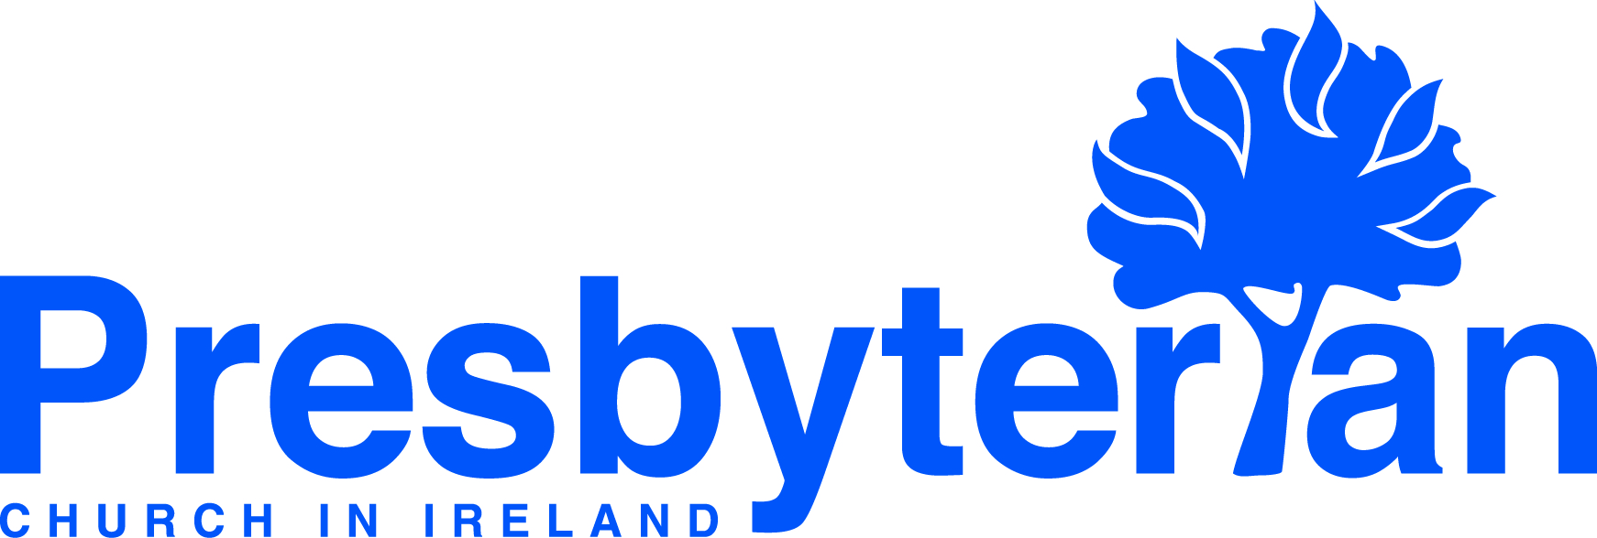
Let’s Pray | Sun 5 Dec - Sat 11 Dec 2021
Saturday 11 December
- General Council | As the faculty at Union Theological College prepare for 2022, pray for a new generation of ministers who may be sensing God’s call on their lives.
- Training in Ministry | Union College Management Committee meets on Monday 13 December to review the work of this term and plan for next year. Give thanks for successfully completed projects on the Library ceiling and the replacement of the heating system, both of which went smoothly and were within budget. Pray for the Committee with all of the matters before it this week.
Friday 10 December
- Social Witness | Please remember Dermot Parsons, the new Director and Secretary to the Council for Social Witness. Give thanks for his appointment and pray that God will guide and bless both the Council and Dermot in the months and years ahead.
- Council for Public Affairs | Rev William Hayes convenes the Republic of Ireland Panel which exists to articulate
the distinctive public affairs responsibilities and challenges facing PCI within the Irish Republic. Pray for wisdom
and guidance for William and the Panel as they seek to make a positive contribution to the public square.
Thursday 9 December
      - Joanne Dunlop (deaconess in Craigavon and Antrim hospitals) | Give thanks and pray for all the staff in our hospitals doing tremendous work in exhausting and difficult times. Remember especially the staff working in our intensive care units. Pray for opportunities as chaplains to support and encourage all the staff.
      - Aghada & Cork | Pray for a county-wide revival, a repentance from all sin and a great Spirit led blessing of love for God and each other. Pray specifically for people not to let fear stop them from loving God & their neighbours.
Wednesday 8 December
- Gary and Mary Reid (global mission workers, Kenya) | Give thanks for the recent much-needed rainfall in the Olkinyei area. Give thanks too that the Mission has been able to provide new windows for a local primary school. Pray for the church families and that God’s Holy Spirit will continue to bind his children together in unity and that their love for one another will be a witness to those who do not yet know the Lord.
- Nepal | Pray for the work of Minority Focus, Nepal and the Association for Theological Education, Nepal.

Tuesday 7 December
- Eleanor Drysdale (deaconess in Wellington, Ballymena) | Give thanks that organisations in the congregation are gradually able to resume again and pray for wisdom in moving forward. A number of people have taken this opportunity to step back from being involved as leaders or helpers, so pray for new leaders / helpers.
- Belvoir (South Belfast) | Pray for the life and witness of the urban mission congregation of Belvoir as members celebrate Advent and the birth of Christ.
Monday 6 December
- JETS (Middle East) | Give thanks for the work of JETS as it seeks to equip spiritual leaders for planting and strengthening churches in the Arab world. Pray for staff at JETS who are coming towards the end of their current assignment at the College and as they readjust to life in their home countries.
- Indonesia | Pray for the Evangelical Christian Church of Halmahera, for wisdom for its leadership team, for unity in the church and for leaders and members to build good relationships with their Muslim neighbours.

Sunday 5 December
- Moderator | Give thanks to God for the many longstanding partnerships across the world which PCI has had.
Pray for our partners, especially those worst affected by the pandemic.
- Worship as an act of faith and love this Christmas | ‘I am the Lord’s servant,’ Mary answered. ‘May your word to
me be fulfilled.’ Then the angel left her. Luke 1:38. Pray that we might approach worship this Christmas season with
all that we are, offering our lives afresh in faith and love to God.
confidence in his power as we worship today.

