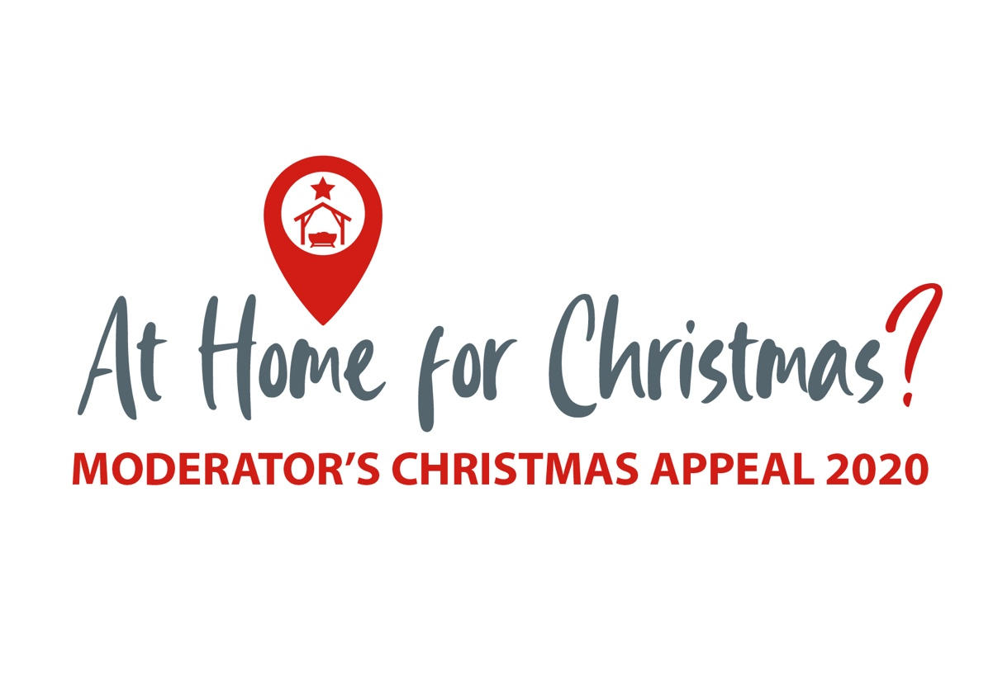

**Sharing Stories**

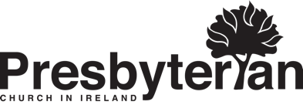

## **From South Sudan**

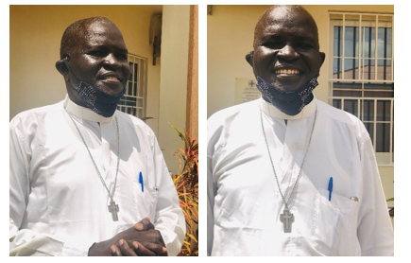

**Alongside his work as a full-time pastor, Rev Canon Emmanuel Nattania Bandi, serves as a volunteer counsellor with a coronavirus helpline in South Sudan**.

For him, this is a natural extension of his calling as a pastor. He says, *“I was called to care for people and as a counsellor my work is to help my people who are distressed and helpless.”* The helpline is run by a Christian Aid partner and supports those impacted by the virus as well as supporting frontline healthcare workers and carers. The helpline also tackles fake news about the pandemic which increases fear. Rev Emmanuel believes that the trust built up between the churches and the people in South Sudan means that faith leaders are viewed as reliable sources of information in curbing the needless spread of coronavirus.

**Christian Aid/South Sudan Council of Churches**

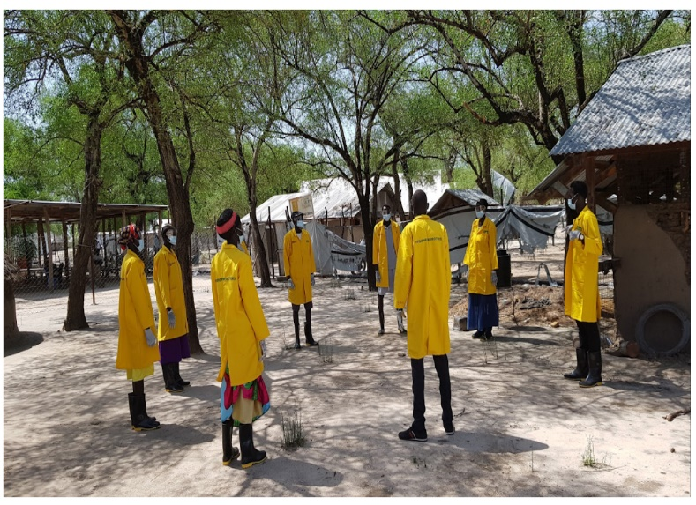

Nyra is a Community Nutrition Volunteer in Uror, South Sudan. She received training on Covid-19 symptoms and preventative measures through Tearfund. One preventative measure is setting up ‘tippy taps’ – a simple device to allow hand washing with running water. A container with a small hole near the cap is filled with water and tipped with a stick and rope tied through a hole in the cap. As only the soap is touched with the hands, the device is very hygienic.

**Tearfund**

Nyra has shared health messages in four villages and also raised awareness of coronavirus preventative measures amongst carers of malnourished children, and expectant and nursing mothers attending the Motot Feeding Centre. She is able to advise those coming to the centre to wash their hands before entering and to sit safely distanced whilst waiting for treatment. Nyra shared that many remote villages are not aware of the measures that can be taken to prevent the spread of coronavirus and is committed to her work to bring health messages to protect people in these communities.

Community Volunteers, like Nyra, mean that families, like Cecilia’s, can be reached with the right information about coronavirus. Cecilia says: *“I was worried and confused with my kids not knowing what to do since I don’t have a radio and people were confusing me with different information in regards to Covid-19… I am now enlightened about the disease and I will take what you have taught me seriously to prevent the spread of the disease.”*

**Democratic Republic of Congo**

**Fatuma is a 25 year-old married mother of six children from South Kivu province in the Eastern Democratic Republic of Congo (DRC) where she and her husband both worked as farmers to support themselves.**

Earlier this year fighting between the Congolese army and a local militia forced Fatuma and her family to flee for their lives, joining the over 1.4 million people displaced by conflict in DRC between January and June this year.

The family are now living with a relative. The house they are sharing has only two rooms and is now occupied by sixteen people in total. Physical distancing would be impossible should someone fall ill. Fatuma is deeply worried about coronavirus but the families’ sleeping conditions are not the only thing increasing their risk of catching coronavirus. With a population of nearly 90 million people, less than 1 in 20 people have access to soap and water at home in DRC, Fatuma’s family included.

Christian Aid’s local partner, ECC-MERU, has provided Fatuma and her family with jerrycans to help the family be able to gather and store water for use at home, as well as soap. The coronavirus awareness raising carried out by ECC-MERU has helped Fatuma learn about the symptoms of the virus, as well as how it spreads, helping to keep her and the two families as safe as possible. She says, *“Through the local radio and posters, they have helped us to learn about how to avoid catching coronavirus and passing it on. I have also started washing my hands before breastfeeding and have started wearing the face mask I received when I go to church.”*

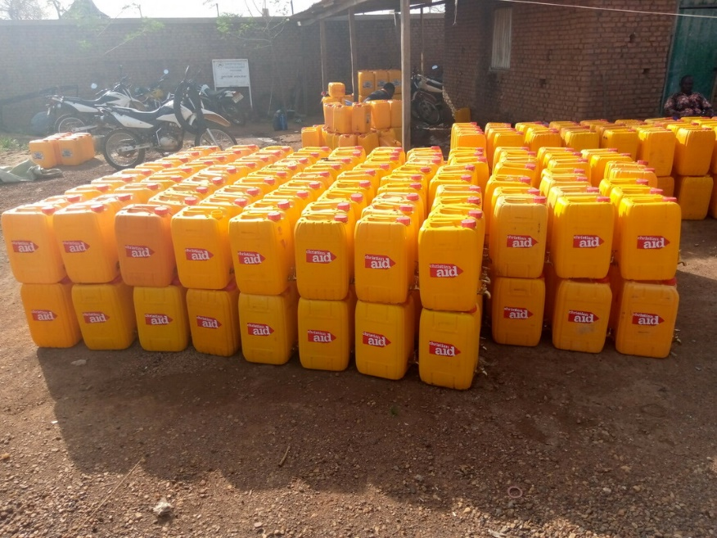

**Christian Aid/Mabe Richard.**

**Cox’s Bazar, Bangladesh**

**Jubaida arrived in Cox’s Bazar, Bangladesh, having fled Myanmar during 2017 with her seven siblings after losing their parents.**

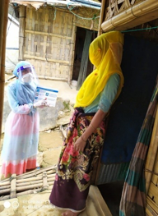Now 18 years old she is working as a community health worker, making door-to-door visits in the refugee camp, providing general health advice and more. She received specialist training from Christian Aid’s partner DAM (Dhaka Ahsania Mission) whose community health workers have been instrumental in reaching Rohingya refugees with coronavirus awareness training since March 2020.

As Jubaida explains, delivering reliable information about coronavirus is of paramount importance as the living conditions of the refugees put them at heightened risk of catching the virus: *“Parents want to keep their children safe from this deadly virus but overcrowding in the camp makes the refugees vulnerable, the Rohingya people live in flimsy shelters with up to ten or more people in one room and they have to share toilets. There is also not a lot of space when they collect food which makes social distancing difficult.”*

**Christian Aid/Sadeka Begum, DAM**

Misinformation about coronavirus and stigma attached to people suspected of having it is also prevalent in the camp and something which community health workers are actively working to counter. Because Jubaida herself is a Rohingya refugee, she has been able to gain the trust of her community which has been key to their acceptance of her advice about coronavirus.