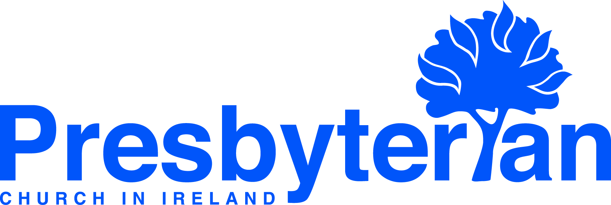
Let’s Pray | Sun 21 April - Sat 27 April 2024
Saturday 27 April
- General Council | Pray for the ongoing meetings of the Irish Inter-Church Committee. Remember especially Rev Helen Freeburn and Rev Barry McCroskery as they represent PCI on the Inter-Church Committee.
- Training in Ministry | Third year ministry students are due to have what’s known as an “Exit Interview”. The student, a member of college staff and a member of presbytery meet to review the student’s training. When satisfactorily completed, the student is considered for licensing by his or her presbytery, usually in June. Give thanks for these students and pray for them as they reach the end of their college training.
Friday 26 April
- Social Witness | Pray for Elaine Glass, office manager and PA to the Director of the Council for Social Witness. Remember Elaine in this busy role as she oversees the administrative team, as well as working closely with the Director and Regional Managers to ensure best practice throughout our services. Give thanks for Elaine’s willingness and commitment to her role
and for all that she brings to it.
- Education | Pray for young people and teachers during this busy term. Pray especially for those young people
preparing to take their GCSEs, AS/A-levels and Leaving Certs. Pray for teachers, that they will be able to help students prepare and offer encouragement. Thank God for teachers, for their care and enthusiasm as they teach.
Thursday 25 April
      - Donegal and Stranorlar | Pray for the congregations as they meet together in this time of vacancy, that they would be a continued witness to their local community and would know God’s provision.
      - Ben Cavan, community outreach worker, Ballycrochan, Bangor | Pray for the inaugural ‘drop-in’ weekend away, that much fruit would be borne for the kingdom. Pray for a ‘prayer space’ event with the local school, that many pupils and staff would encounter God.
Wednesday 24 April
- Derek and Jane French, global mission workers, Spain | Pray for the distribution of the booklets, such as ‘Knowing the Good News’, that have been translated into Spanish and Basque. Give thanks for people, such as Veronica, who are faithful to the Word of God and diligent in this important translation work.
- United Mission to Nepal (UMN) | Pray for UMN as they begin the process of developing their strategy for the next five years, especially for the development of terms of reference, the selection of a consultant, and the drafting of a strategy that will facilitate UMN in fulfilling its vision and mission.
Tuesday 23 April
- Graham Stockdale, prison chaplain | Pray for Graham as he supports staff and those in Maghaberry pastorally, that he would know the Lord’s strength and provision as he speaks hope into people’s circumstances.
- Dundalk | Give thanks for God’s Word and pray that it would dwell richly in the congregation’s hearts, helping them to grow and be fruitful. Pray that more people would be added to the church musical team as they lead in worship.
Monday 22 April
- Naomi Keefe, global mission worker, Brazil | Continue to pray for the Good News Club, for Reading in the Park, and for the training sessions with the volunteers. Pray especially that as people hear the good news of Jesus Christ, many would come to place their trust in him as their Saviour and Lord.
- Faculté Jean Calvin (FJC), France | Give thanks for all engaged in strategic theological training at Faculté Jean Calvin in Aix-en-Provence, especially that this training will effectively prepare students for ministry and mission in the French-speaking world.
Sunday 21 April
- Moderator | Pray for the farming and horticulture communities facing a challenging situation owing to the extremely heavy rains being experienced. Pray that the rain would ease and for resilience and grace for our farmers and families
as they face huge financial, emotional and mental pressures.
- Worship: Expressing our praise | As we worship today ask God to help us to do so with hearts grateful and thankful for
all he is to us and does for us.

