PUBLICITY INFORMATION FOR CHURCH ANNOUNCEMENT
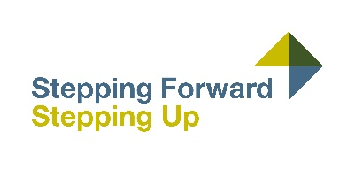

CALLING ALL YOUNG NEW/EMERGING LEADERS
Have you been thrust into the leadership limelight in your congregation recently? Are you unsure about how you got there or what you’re supposed to do? Would you like to gain some practical tools that will help you lead well in this and every season of church life? If so, Stepping Forward: Stepping Up is for you. Stepping Forward: Stepping Up is a new, hybrid training programme of two in-person and two online sessions, designed to encourage, empower and equip young, new and emerging leaders aged 16+ as they take their first steps into church leadership. Delivered by PCI’s Council for Congregational Life and Witness, this training programme will begin on Saturday 28 January at 10am in Assembly Buildings, Belfast, and provide a mix of personal teaching, practical workshops, group discussion, and leadership lessons from a variety of contributors.
The cost to attend Stepping Forward: Stepping Up is £25 per emerging leader. Please note, there will be no charge for a youth worker or other experienced leader attending with young people from their congregation. For more information and to book, visit www.presbyterianireland.org/steppingforward

