PUBLICITY INFORMATION FOR CHURCH ANNOUNCEMENT
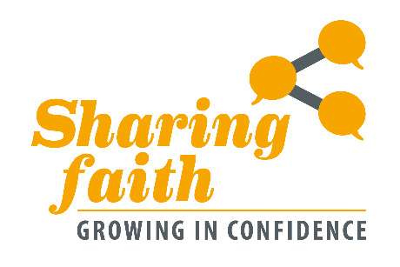
Perhaps you have a deep relationship with Christ and an active commitment to your local church, yet find yourself tongue tied in talking about your faith with friends, colleagues and neighbours.
Through a hybrid format of two in-person and two online gatherings, this four-session, informative and interactive programme aims to help participants to better understand the challenges for evangelism today, and equip them to grow in confidence and the conversational knack of talking about the good news.
Delivered by PCI’s Council for Congregational Life and Witness, this training programme will begin on Saturday 4 February at 10.30am in Assembly Buildings, Belfast, and provides a mix of personal teaching, practical workshops, group discussion, and leadership lessons from a variety of contributors.
The cost is £25 per person. For more information and to book, visit www.presbyterianireland.org/sharingfaith

