Children’s Activity // Wise Men
Animation
Play the short animation that comes with this resource entitled “Wise men”.
Introduction
The other key visitors after the birth of Jesus were the wise men. Their home was in Persia – that’s what you would might know as Iran. They travelled a very long way to see Jesus, because they received a sign that he was to be born. The sign was a new star in the sky. These men left their home, not knowing where they were going or how long it was going to take them. What they did know was that they had been waiting for a special sign and when they saw this star, they knew that this was it. They needed to load up their luggage and the special gifts that they had. They would then travel for as long and as far as they needed to so that they could meet the new king.
They ended up going to the wrong place and alerted Herod to the birth of the new king, but God was in control and redirected their path home after they had seen Jesus.
They brought him gifts to welcome him into the world. Gold for a king. Frankincense for worship. Myrrh was a spice used in death and so this was to symbolise the sacrifice that Jesus would make on the cross when he died.
Bible story
The story can be done in different ways depending on preference and what you have available.
Read from the Bible Matthew 2:1-12
Reading or video option Jesus Storybook Bible “The King of all kings”. The videos are available to buy as part of the JSB curriculum or you could search online.
Or Max7.org “The wise men came to worship baby Jesus” www.max7.org/en/resource/wisemencometoworship
Song suggestion
Come and join the celebration by Valerie Collison www.youtube.com/watch?v=pMqG5M76tFE
Underneath the Shining Star by Keith and Kristyn Getty https://www.youtube.com/watch?v=TelIRUwgziQ
Activities
Map
– show on the map where the wise men travelled from Persia (modern day Iran) to Bethlehem.
Advent wreath
This week’s advent addition is a star. Below is a star template that can be coloured, cut out and stuck to the wreath. The children and their families should now have 3 items stuck to their advent wreath.

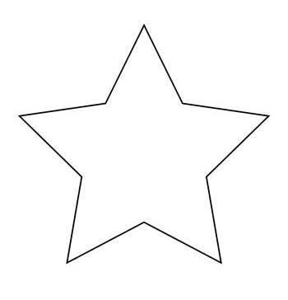

Make a 3D paper star
(instructions below)

Materials needed:
- 12”(30cm) x 12”(30cm) Christmas Scrapbook Paper or Coloured Card
- Scissors
- Pencil
- Double-sided Tape or Paper Glue
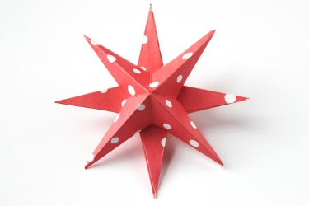

Directions:
1. Take a square of paper and fold in half. Open out, rotate 90 degrees and fold in half
again.
2. Open out and fold your paper in half again this time along both diagonals.
3. Flip the paper over and mark a little less than halfway down each of the horizontal
and vertical creases.
4. Cut down to the pencil marks.
5. Fold the paper in on each side of the cut to form a point.
6. Repeat on all remaining sides.
7. Apply glue or double-sided tape to 1 side of each of the points.
8. Peel back the tape and fold 1 side of the point over the other and stick down.
9. Do the same on the remaining points to make half a star.
10. Repeat the steps above to make the 2nd half.
11. Apply some more glue to the centre corners or each point.
12. Stick both halves together making sure the points are at 45 degrees from each other.
13. Leave to dry and hang.

