Children’s Activity // Shepherds
Animation
Play the short animation that comes with this resource entitled “Shepherds”.
Introduction
The first people to hear of Jesus’ birth were the shepherds in the fields surrounding Bethlehem. These shepherds did not have homes. They lived in the fields, sleeping under the stars, with their flocks. In fact, people didn’t like the shepherds very much. They were not trusted as they constantly moved from place to place. But God loved them and he trusted them enough to be the bearers of the good news to everyone else.
How do you think the shepherds would have felt about being told the news about Jesus’ birth first?
The shepherds would have been really surprised to hear the news of Jesus’ birth first. Being on a hillside and having firstly a single and then a whole choir of angels appear would have been shocking enough, but to know they heard the news first as unimportant shepherds would have been astonishing. It may not have been something that they had time to think about until they were on their way back to the fields having seen the baby Jesus. They still had no homes to go to but they had a new importance and understanding of God’s love for them.
Bible story
The story can be done in different ways depending on preference and what you have available.
Read from the Bible Luke 2:8-16
Reading or video option Jesus Storybook Bible “Light of the whole world”. The videos are available to buy as part of the JSB curriculum or you could search online.
Or from Max7 “The Shepherds” https://www.max7.org/en/resource/Luke2Shepherd
Song suggestion
“How could it be a silent night?” by Martha Bolton & Bob Singleton
https://www.youtube.com/watch?v=tPdtwpaz9IY&feature=youtu.be&fbclid=IwAR26_WUncZfVbsIHsFNVS6IzUxkxCUbNaPfU-Stuj-HFmQHsLxb2FI68Bj4
Activities
Map
– add to the map from last week to show the journey the shepherds made from the hills down to the town of Bethlehem.
Advent wreath
This week’s item to add to the wreath is a sheep. Below is a picture that can be cut out, coloured and stuck on the wreath template from the previous session.

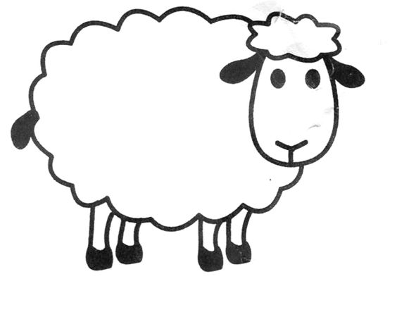
Memory verse
“There were shepherds living out in the fields nearby. An angel of the Lord appeared to them. They were terrified.” Luke 2:8-9 (NIRV)

Have the children do the following hand actions along with repeating the words after you, to help them learn the Bible verse:
There were shepherds: act like you are holding up a shepherd’s staff
Living out in the fields nearby: sweep arms in front of you as though you are showing the fields
An angel of the Lord: hold arms up as in surprise
Appeared to them: close eyes and then open eyes
They were terrified: have a scared look on your face
Luke 2: hold up 2 fingers
8-9: hold up 8 fingers and then 9 fingers

Do this a few times with the children. Make it fun for them to do the actions and say the words. Active learning really helps with memorisation.

