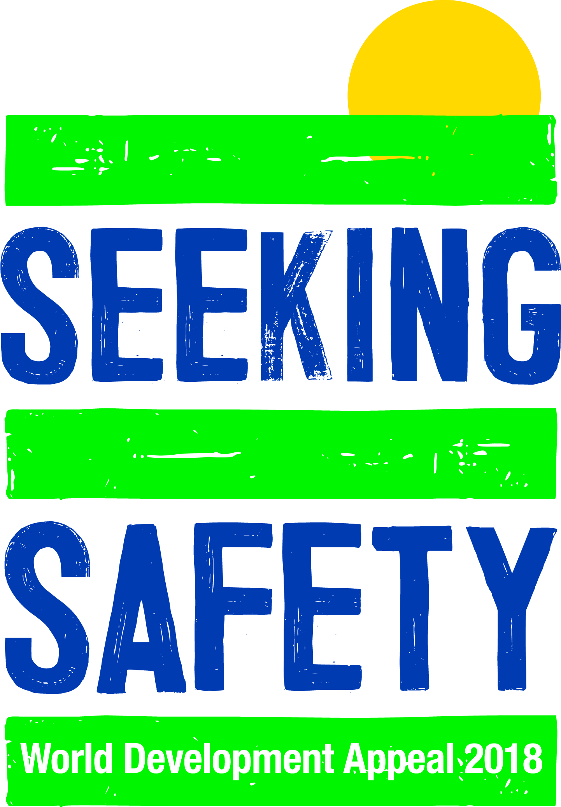
CHILDREN’S TALK
For this talk you will need a couple of pictures or PowerPoint slides as follows: one of a bicycle or car with a flat tyre and one of a torch (not shining) or mobile phone (or something else with a battery in it).
- Begin by showing the picture of the bicycle or car – ask the children if they can see anything that is wrong with it. Hopefully they will pick up on the fact that it has a flat tyre and won’t work as it should.

- Then show the picture of the torch or phone – ask if they can see if there is anything wrong with it. It shouldn’t be immediately clear that there is and the children may say that everything looks ok. You can then tell them that everything is not as ‘good’ as it looks – that were they to try to use the torch or the phone they would find that the battery is missing or flat and that it isn’t working as it should either.

- Sometimes when we look at the world around us it is easy to spot things that aren’t right – perhaps when people haven’t got clean water to drink, or enough food to eat, or a proper house to live in.

- Sometimes it can be much harder to see that things aren’t as they should be – maybe when people aren’t getting on the way they should be, or when someone has a job but they aren’t actually getting paid a fair wage for that job.

- God created a world where everything was as it should be, but because human beings made mistakes and did what God had told them not to do things got messed up and now they don’t always work the way they should.

- God knows this and it makes him sad when people hurt one another, when they don’t care for others who need their help, and when all the resources that are part of his world aren’t shared fairly. And God knows about everything that isn’t working as it should – the things that are easy to spot and the things that are not always so easy to see.

- One day, God will make sure that everything in his world is ‘fixed’ and as it should be – he has promised that and in the Bible we can read about what that world will be like, but until that day he wants people who love him to care about his world and other people like he does and to be alert for things that aren’t the way they should be, the things that are easy to spot and the things that aren’t so easy to spot, and to talk to him and ask him how they could, perhaps, start to make things work better, with his help and guidance, of course.

- The World Development Appeal helps us to have our eyes opened to some of the things that are not working the way God intended them to and the prayers that accompany it and the money that is raised through it help to begin that process of making things a bit more like God planned for them to be – sometimes it is about something that it is quite easy to see is not right like building better houses for people or making sure they can get proper healthcare; and sometimes it is about something that can be a bit harder to spot as being wrong like helping people sell their produce for a fair price or helping men and women and boys and girls behave towards one another with respect and fairness (like in this year’s Appeal).

- And the really special thing about the World Development Appeal and the friends we work with at Christian Aid and Tearfund, who help us to see the things that aren’t working as they should, is that they don’t just fix the problem that is immediately spotted and then move on. They try to see everything else that might add to something not working as it should and they try to help other people see it too, especially people who are close to the problem, and they try to help them think about ways to fix the problem and to begin to fix the other things that are not working as they should too so that the problem might not happen again and things might work better going forward. (If wished, the bicycle illustration could be re-employed here: it might not just be about fixing the flat tyre, it might be about starting bicycle maintenance classes so people know how to look after their bicycles better or maybe even starting a campaign to improve the condition of the roads so bicycles are less likely to get a flat tyre.)

- This is called ‘sustainable development’ and it is really what is at the very heart of the World Development Appeal.

- It is all about people working together to spot the things that are not working as they should and then keeping on working together to make those things better and to try to make sure that there is less chance of them not working like they should again. And we believe this is really important because God is pleased when his people work together to help other people who are in need and because this helps move the world towards being a little bit more like God would want it to be until the time when he puts everything in order… and God might just say that is ‘very good’!

Suggested Children’s Songs
‘God’s Amazing Children’ (Nigel Hemming)
https://www.youtube.com/watch?v=ZwlxrVLQgxA
‘The Body Song’ (Debbie Kerner and Ernie Rettino) https://www.youtube.com/watch?v=Yv5Ge6TJteQ
IPH #276 ‘The Bible Tells of God’s Great Plan’
IPH #146 ‘Jesus Put this Song into Our Hearts’
IPH #29 ‘My God is so Big, so Strong and so Mighty’

