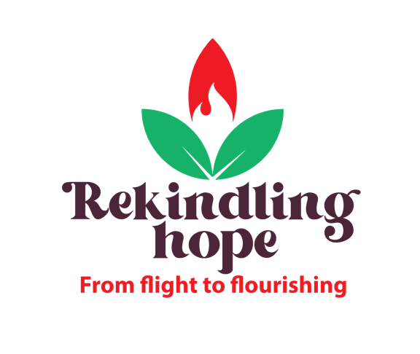

World Development Appeal 2022
Children’s address

Far from Home

Theme: Refugees/migration/conflict/climate change

Aim: To help young people empathise with others whose lives are torn apart by war or environmental disaster; to appreciate the link between our own lifestyles and those forced to leave their homes.

Additional materials/preparation (optional): A selection of essential and personal items including a first aid kit, a phone, a bottle of water, a warm jumper, money etc.

Presentation
- Around the world, many people are on the move.

Some are travelling for holidays or for work. Some are migrants seeking to start a new life somewhere else. And some are forced to move – running away because their lives are in danger. You may have heard terms such as refugees, asylum seekers and displaced people. These names have slightly different meanings, but they all refer to people who have been forced to leave their homes because they were afraid of what might happen if they stayed. Sometimes they leave home to get away from war or being mistreated, and sometimes they are running away from a disaster such as a flood.

- Show the children the selection of items you have brought along.

Ask ‘If you had to leave your home in a hurry and could only take one thing, which thing would you take?’

Ask for a volunteer to come up to the front. Ask them to choose which one item they would take. Why did you choose this item? Was it difficult to choose just one thing? Thank the volunteer and ask them to sit down.

- Ask: How would you feel if you had to leave your home in a hurry? How would you feel if you could never go back?

Explain that most people in the UK and Ireland usually have a choice about when and where they move and usually have lots of time to pack. But some people around the world don’t have a choice – they are forced to leave their homes, often in a hurry.

Christian Aid and Tearfund are charities that work with poor communities all over the world. Often helping to get food, water, clothing and other supplies to people who are forced to move far from home.

In the Bible, we find many examples of how God is concerned and cares particularly for vulnerable people including migrants and refugees. We read stories of how migrants and refugees can be a blessing to us, like in the book of Ruth. We are also given clear instructions through Jesus command to ‘Love your neighbour as yourself’ in Matthew chapter 22.

The World Development Appeal this year reminds us of the opportunity we have to live in peace, and to care for the world and everything in it – including our neighbours in countries like South Sudan and Lebanon.

Let’s take a moment to pray for one another and our neighbours across the world.

Prayer:
Creator God,
You made us to care for the world and for all people. We pray for children who are forced to move away from their homes whatever the circumstances, and pray that they are able to keep safe. Help us do what we can to bring healing to your people.
Amen

