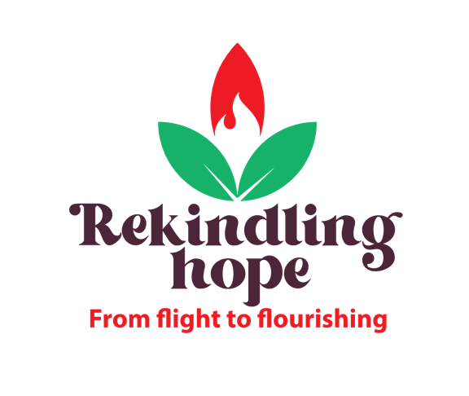

World Development Appeal 2022
The context

Lebanon
Lebanon is a small country in the Middle East – with an area of 10,452 km², it’s smaller than Northern Ireland! Its population is about 6 million, and it has the highest percentage of Christians of any Middle Eastern country. However, the number of Christians is declining due to emigration (85% of the 15 million+ Lebanese diaspora are estimated to be Christian). Some estimates suggest Christians account for as little as 25% of the population (in 1950, this was 50%). Evangelicals are a much smaller percentage.
Despite this, the story is by no means all gloom: God is at work, and stories abound of God transforming lives, often through miraculous encounters with Jesus. Many people have chosen to stay and make a difference. The Tearfund supported Tahaddi Centre, one of the World Development Appeal’s focus projects for this year is a good example of how Christians have sought to rekindle the light of Christ in communities dominated by darkness and despair.
Statistics of the crisis in Lebanon
- In the last three years, the Lebanese Pound has lost around 90% of its value. Inflation is the third highest in the world, resulting in 80% of the population being in poverty.
- Government employees including doctors, nurses and teachers are no longer able to live on their salaries. As a result, 3,000 doctors and 5,000 nurses have left the country since 2019. Although they send back foreign currency to their families, this is a massive brain drain.
- Some 2.2 million Lebanese need humanitarian aid. On top of that, there are 1.5 million Syrian and 200,000 Palestinian refugees in the country.
- In 2020, there was a massive explosion in the docks area, destroying infrastructure, including grain stores, and causing considerable loss of life and trauma.
- The war in Ukraine has had a disproportional impact, as Lebanon imports almost 90% of its grain and sunflower oil from Russia and Ukraine.
- Four out of ten school-aged migrants and refugees are not enrolled in education. In addition, 14% of Lebanese children dropped out during 2020-2021, with growing fears of a lost generation.
- Syrian refugee families in informal settlements are among the most vulnerable. Almost all refugees are in debt and have had to cut spending on essentials, including food.
- Child labour among Syrians doubled in 2020 and some 25% of refugee girls aged 15-19 are married.
The Tahaddi Centre
The Tahaddi Centre is in an area of considerable deprivation. The community is predominantly made up of Syrian refugees, undocumented Lebanese and Dom (a traveller people historically from the Indian sub-continent).
The area houses thousands of people, maybe even tens of thousands. No one knows. These people are undocumented, living in congested, multiple-occupancy housing in an area with utility provision for perhaps 50 houses. There is little running water, sewage provisions or electricity. The buildings are ramshackle concrete constructions that are prone to collapse.
The place is drab, dull, even dirty. There is raw sewage on the streets. Education and employment opportunities are minimal. Many of the children are not in school and some are forced to work. Most adults rely on sporadic manual labouring jobs. As a result, physical and mental health problems are common. The cycle of poverty is passed down from one generation to the next, with little prospect of this cycle being broken.
The Tahaddi Centre stands in marked contrast to the community it serves. It is colourful and bright, the staff are energetic and enthusiastic. They speak of hope, they show love and compassion, they serve sacrificially, making a real, significant difference to the people of the community.
The Centre, founded about 25 years ago, provides education for children who cannot access it or have dropped out of the public school system. The demand for places outstrips the supply, so much so that the centre now provides three consecutive teaching sessions for children. The joy on the children’s faces is testament to quality of teaching and the commitment of the staff.
In addition, there is a small, basic health centre and a sewing workshop for up to 20 women. The approach is holistic; there are social workers following up with families, psychosocial support is provided to those who have suffered trauma. There is an awareness of the need to address the wide ranging needs of the community, from education to health, employment to food supplies to housing.
Tahaddi means ‘challenge’ in Arabic, and there are plenty of challenges to be faced. Tahaddi’s aim is to challenge poverty and, through its key values of justice, integrity and compassion, to rekindle hope.
Speaking about the Tahaddi Centre, Tearfund’s Farah Bou Kheir says “this is where your faith shines… The situation is very tough. You see God is in action and you have a call…to be agent of hope, to be agent of change. And you don't know how God is working with the hearts of those people.
It's like an act of worship. They are worshipping God by being cheerful givers to a place, which is very needy… so that those who are receiving would be thankful… So you can see how the role of the church when it comes to resources is tying both communities together, the giver and the receiver.”
Farah describes the centre like a lighthouse. He says “Giving to the World Development Appeal is an invitation for the church to be present in this context, and to be the hands of Jesus that extend the hand of compassion to a needy community…to address the needs of the vulnerable and to be the light in the dark spots.”
Lebanon is not an easy place to live, for most, but in the midst of the darkness, God is moving, shining His light through places like the Tahaddi Centre.

source: Echo Factsheet ECHO Factsheet - Lebanon (Last updated: 10/05/2022) - Lebanon | ReliefWeb

