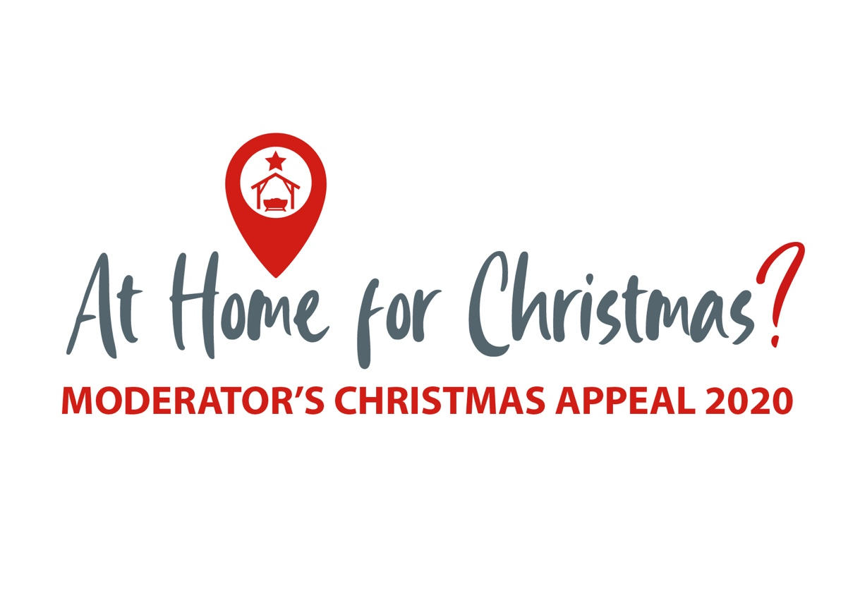

**Information Document**





**When news of a new, acute, respiratory disease in Wuhan, China, broke as 2019 drew to a close, few of us could have anticipated what followed. The spread of the SARS-CoV-2 virus has been rapid and has affected nearly every corner of the world. Coronavirus has become part of our every day and we have all had to adapt to new routines of hand hygiene, wearing face coverings, and practising social distancing as well as learning a whole new lexicon of terms such as ‘flattening the curve’, the R-number, and support bubbles, with WFH (working from home) becoming one of the most frequently used abbreviations.**

There is no doubt that Covid-19 has impacted the contexts in which we find ourselves. Even as this material is prepared we find ourselves here, on the island of Ireland, facing increased restrictions to tackle a second wave of the virus and we read in our news feeds of the mounting pressure on our hospitals and health care providers. And as we look ahead to Christmas we are all too aware that, this year, there will be many ways in which coronavirus will bring change and challenge to the landscape of the Christmas season.

We may not be able to have large family gatherings in our homes or to welcome family who live in other places home for Christmas; we are anxious as to whether our young people will be able to return home for Christmas from studying or working further afield. We acknowledge that for some ‘home’ may be a place of loneliness or isolation over the Christmas period, an extension of the months of loneliness of lockdown. We recognise that for others ‘home’ might not feel secure or safe, perhaps because of financial anxieties, perhaps because of uncertainties around employment prospects, perhaps because of broken or abusive relationships. Even in the context of our church families, we will not be able to be ‘at home’ together in our church buildings engaging in our normal patterns of preparing to welcome the Christ-child, come and coming, or of inviting others in to hear the amazing news that in this season God ‘moved into the neighbourhood’, that, in the infant Jesus, all the might and majesty of heaven came to dwell in the midst of the muck and mess of humanity.

‘Immanuel – God with us’ (Matthew 1:23): that’s something that coronavirus can’t impact in this coming Christmas season or in any season of our living. On that very first Christmas the King of kings and Lord of lords was not ‘at home’ in the heavenly realms but took on flesh and lay mewling in a feeding trough watched over by a peasant couple who were not at home having made their way to Bethlehem for the Roman governor’s census, visited by shepherds who were not at home but out in the fields watching over their flocks, adored by Magi who travelled far from home to greet a new King at His birth. On that first Christmas God shared and showed His love for His people by sending His Son who gave up His heavenly home that, by grace and through faith, we might have one. This is the Christmas story we have to tell: the story of a rescuing, redeeming, restoring God who has a heart for the excluded and marginalised and for those far from Him and who invites His people to share that heart, declaring good news and demonstrating His love.

Coronavirus has affected us all. We live in an increasingly globalised world, a world in which we might well feel that we have more than ever before in common with neighbours near and far as we stand in the midst of a global pandemic. As such, we also have the opportunity to be global disciples, sharing God’s heart for the world, as never before. Whilst remaining aware of the challenges facing many in our local contexts, we would not wish to ‘look the other way’ when faced with the need of some of the most vulnerable of our global neighbours, living in countries with fragile infrastructure and economies, where healthcare systems are simply not equipped to deal with a pandemic, and where food poverty is already a reality for many.

We know the Covid landscape is challenging in all sorts of ways and we look out on it as those who know the benefits of having access to what we need to protect our health, of government support schemes, of relative steadiness in our supply chains, and of the provision of the NHS with its dedicated frontline medical staff. Around the world there are yet millions who look out on that landscape from a place of desperate need due to poverty, climate change, conflict, and disasters. Global neighbours in countries where there aren’t enough doctors, ventilators, or ICU beds. Global neighbours facing the choice between obeying restrictions and having no income to feed their family. Global neighbours who now have no job and for whom there is no safety net or government support.

Families who have fled violence, conflict, and hunger in the place they knew as ‘home’ are particularly vulnerable. Many are now living in crowded refugee and displacement camps and have little access to medical care, clean water, or enough food, making them extremely susceptible to contracting coronavirus. And in these contexts, the virus is likely to exact a deadly and devastating toll on those who have already lost so much.

Surveying this landscape, where the impact of the pandemic is threatening to push the struggle against poverty back by decades, the Presbyterian Church in Ireland has felt called to launch a Moderator’s Christmas Appeal in response to the Covid-19 global pandemic. Scripture reminds us that “If one part of the body suffers, all the other parts suffer with it…” (1 Corinthians 12:26). The Moderator’s Christmas Appeal invites us to stand in solidarity with our global neighbours, in particular those who do not have a safe ‘home’ within which to weather this latest storm but who must face the onslaught of Covid-19 in fragile and precarious places and conditions.

The monies raised by the Appeal will be divided three ways: one third to each of PCI’s relief and development partners Christian Aid and Tearfund as they work into the Covid crisis with their partners on the ground (see supporting information for further details) and one third to PCI partner churches and organisations in South Sudan, Romania, Lebanon and Syria, Indonesia, Nepal, and Malawi. Details of how to give can be found in the accompanying letter.

As you read the supporting information and stories might we invite you to share details of the Appeal with your congregation and to invite them to respond as they feel able. And whether responding by giving is an option or not might we invite you to respond prayerfully for our development partners, our partner churches, and for all those with whom they are working on the ground, those who are facing Covid-19 without adequate healthcare provision, without sufficient food, without basic sanitation… without a place to call ‘home’.

*“So the Word became human and made his home among us. He was full of unfailing love and faithfulness…From his abundance we have all received one gracious blessing after another.” (John 1: 14, 16 New Living Translation)*