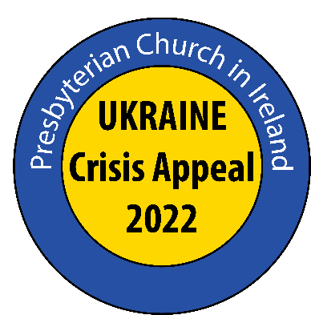
Moderator’s Appeal for Ukraine 2022
PowerPoint Script

Slide 1
In response to the ongoing devastating war in Ukraine and exodus of people from the country, the Moderator of the Presbyterian Church in Ireland has launched an Appeal towards the emergency relief effort to help people in Ukraine and those fleeing the conflict.

Slide 2
Calling on PCI members to consider their response to this humanitarian emergency, Dr Bruce said, “Further to my letter last week calling for congregations to pray for the situation in Ukraine, tragically the bombardment of Ukraine and its people by President Putin’s forces has continued, and the fear and suffering of people living in the country has increased each day. The United Nations estimates more than a million people have fled the country due to the war so far, and many more are expected to follow.

Slide 3
The Moderator has launched a Special Appeal towards the emergency relief effort to help people in Ukraine and those fleeing the conflict.

The Presbyterian Church in Ireland is immediately releasing £60,000 (€72,035) to be distributed between its relief and development partners Christian Aid and Tearfund, and also to its global mission partner, the Reformed Church in Hungary (Hungarian Reformed Church Aid).

They are all experienced in supplying and distributing humanitarian aid and assistance, not least to refugees and displaced people fleeing regions of conflict, and whenever possible, will extend their reach into Ukraine itself.

Slide 4
Hungarian Reformed Church Aid was among the first organisations to mobilise its staff and volunteers to provide immediate assistance. The charity organisation of the Hungarian Reformed Church delivered its first food packages to the Ukrainian-Hungarian border on Thursday morning 24 February, and has already send more than 10 tons of non-perishable food worth around €22 000 across the border.

They have also been welcoming people fleeing the war at train stations and at the border, distributing food, tea and drinking water, provided interpretation assistance and transported them to nearby shelters or public transport hubs.
In conjunction with the Hungarian Reformed Church’s Bethesda Hospital, they are also providing medical assistance to people arriving in Hungary and also sending medical supplies to Transcarpathia, Ukraine.

Slide 5
Christian Aid (Ireland) and Tearfund are working with a range of partners on the ground in neighbouring countries and hope to work inside Ukraine as and when circumstances allow. Their partners are providing for the immediate needs of the huge numbers of people fleeing Ukraine every hour. They are working round the clock providing things such as food, bedding and temporary accommodation to the people. In recent days one of their local partners has distributed 28 tonnes of food supplies and other lifesaving essentials to displaced people in Ukraine.
£30 could provide essential hygiene supplies for three people for one month
£50 could provide blankets for four families
£100 could provide emergency food for two families for one month.

Slides 6 & 7
Prayer Points
- Pray for an immediate ceasefire and an end to the war. Pray too for a
de-escalation of the tensions between Russia and Western countries.
- Pray for all affected by the war, especially the grieving, the injured, and those whose homes have been destroyed. Pray for people sheltering in fear, those fighting for freedom and those protesting for peace.
- Pray for the large Christian community in Ukraine. Pray that they will know the Lord is with them in these difficult days and turn to him for their refuge strength and hope. Pray too that they will be a witness to others in these days of distress and fear.
- Pray for those who have recently fled or are fleeing due to the war in Ukraine or have been displaced within Ukraine. Pray they will find safety, shelter, water, food and medical help. Pray they will receive both emergency humanitarian aid as well as help in for in the coming weeks and months.
- Pray for aid agencies and governments trying to help bring humanitarian aid to refugees and people living in Ukraine, including Christian Aid, Tearfund and Hungarian Reformed Church Aid.

Thank you

