Children’s family prayer activity - A week of prayer
Things aren’t just as they normally are just now – schools are closed, shopping centres are closed, leisure centres are closed, McDonalds is closed!!
Maybe you are feeling sad or anxious but we know that our God is a great God, and he is always with us.
"And the peace I give is a gift the world cannot give. So don't be troubled or afraid" John 14:27
We can pray to God at any time, but this Sunday we are having a special hour of prayer, where I have encouraged all of our Presbyterian churches to pray, with all other churches that God would help us in this time of trouble
You can pray too! I encourage you to use the prayer points below to pray. You can do them all together, or one each day!
Why not do some of the activities, take a photo of it and send to me at moderator@presbyterianireland.org

- NHS / HSE
NHS stands for the National Health Service which operates in Northern Ireland and the HSE, the Health Service Executive, works in the Republic of Ireland Both provide public health services in hospitals and communities across the country. The people who work for the NHS and HSE are doctors, nurses, assistant nurses, porters, secretaries, physiotherapists, ambulance drivers, cleaners, cooks, occupational therapists.
- Can you think of any others?
- Do you know anyone who works for the health services?
Talk about how they are helping others

They are very brave at the minute and we want to pray for them.
Nought and crosses prayer
You will need: a grid of three squares by three squares (the same as a noughts and crosses grid).
Write or draw one health service job in each square. Each person chooses something on the grid to pray for and marks it with their initials. The challenge is to get three in a row, but keep praying after that too!
doctor | nurse
 | cleaner
 |  | cook
Pray
Dear God
I want to pray for the people who work for the health service who are helping people in hospital and at home. Please keep them safe from the virus. Give them good health and energy and strength as they work long hours. Be with those who are being trained to do new jobs. May they be brave and know that YOU are with them. Amen
Do
- Print out or draw a picture of praying hands.
- Colour it, write the word pray and put it in your window, so people know you are praying for them.
- Today you can also add a picture of a nurse, or doctor, or the letters NHS/HSE to show you have prayed for them

- Family

To help us remember to pray for each of our family members – we decorated some lollipop sticks with our names. Why not do the same? You can swop each day so that each person in your family prays for a different person.
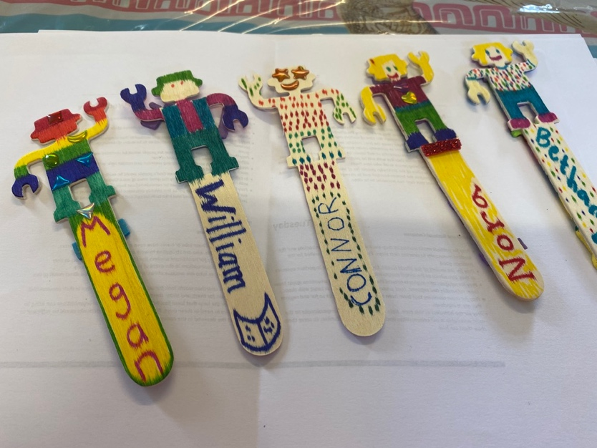

Some people in your family may be very anxious about the future – they are worried about getting sick, worried about money or their older family members. You might even be sad or anxious about not being at school or missing your friends. Remember God says I will never leave you or forsake you” Joshua 1:5.
Play a guessing game
Give clues about different animals, ending with this one:
- This animal lays eggs.
- Some of them live in the ocean, some in the desert, and some in the forest
- This animal walks very slowly.
- This animal has a shell that protects his body and is used as a place to hide.
A turtle can help us remember that God is always with us no matter where we go or whatever happens. The hard shell protects the turtle from other animals -the. turtle cannot walk away from its shell. When we see a turtle we can be reminded that God is always with us no matter where we go and that he protects us.
Pray
- For all of your family, including those you may not be visiting for a while.
- Pray for those who are anxious about money and jobs
- Pray for those who are ill
- Pray for the health workers
- Pray for the elderly and grandparents
- Pray for people who are worried about their health or the health of their loved ones

Do
- Colour a picture of a turtle to remind you that God is with you.
- You could stick on bits of eggshell or stone to make a hard shell.

3. School
- What is your teacher’s name?
- Who are your friends at school?
- What do you miss most about school?
- Are you enjoying working at home?

Coloured prayers
You will need: jelly babies, or bits of coloured paper

Take out a coloured jelly baby and before you eat it pray:
- Green – Thank God that we can still go outside and enjoy fresh air and for extra time we have to play games and enjoy our family
- Red – Pray that God will help you with your work at home, and your parents as they direct you
- Yellow – Pray for all your friends, that they may be safe and know God’s love
- Pink –Pray for teachers as they work on line, and may find it difficult.
- Purple – Thank God that we have his power and it helps us in everything we do. Pray for friends who don’t know about God’s love
Pray
- For your teacher as they set work for you in a different way
- For your class and the friends you miss
- For those looking after you during the day
- For yourself as you may be sad about missing school and anxious.
- For any older students who are keeping up with university work and doing on line exams
Pray
Dear God
Thank you for the children of our school We pray that they would feel relaxed and happy at home, and able to keep up with their schoolwork. Be with our teachers as they prepare. We pray for all parents and families at this time. May they be drawn to know more of you and come to a saving faith. Amen

Pray
Dear Father God,
we pray for all the young people of our church, and those who attend the youth organisations. Teach them that you care for each of them. Help them to show that they love you when they are having conversations with their friends, we pray for those who are lonely, upset, worried or under pressure. We pray for those who are at university and doing on line exams and for secondary school students who are unsure of what is happening with exams. May they all know your presence and seek you. Amen

Aeroplane prayers
Hide A4 paper sheets (numbered 1-10) in different places inside and out.
Who was the best at finding them? If you were playing hide-and-seek with God, he would win every time. There's no place we can hide where God is not already there. The great thing about God is that he doesn't try to hide from us! He is EVERYWHERE all the time, and he wants us to find him! We can never escape the presence of God. Are there times when you may be afraid? God will never leave you. Pray to him
Write or draw a prayer on your A4 paper – fold it into a paper aeroplane. Write GOD on a large sheet of paper on the floor and throw your paper aeroplane to land on the paper. Our prayers go straight to God’s ears and he hears each one of them. Even if our planes might miss the mark but our prayers won’t – they always reach God.

4. People who are sick, at risk or sad.
Many people are sick with this virus, and feel scared. Others are alone at home and are afraid because they are old. Fear can feel HUGE and overwhelming. If you want to, you can write your fears about the coronavirus disease onto a piece of paper. But then, you can stick love-heart shapes on top of those fears, completely covering them, as a hope or a prayer to be set free from fear.
1 John 4:18 “There is no fear in love, but perfect love casts out fear.” That perfect love comes from God. God is always with us, he sent his son to die for us. There is no greater love.
Tissue prayers
Tissues are fragile. They tear easily. Think about someone you know, or groups of people (e.g. those who are elderly or homeless) who may feel ‘fragile’ or vulnerable or lonely. Decorate a tissue box. Each time you take a tissue remember to pray for them
Keep the tissue box in your kitchen remind you to keep these people in your thoughts and prayers.
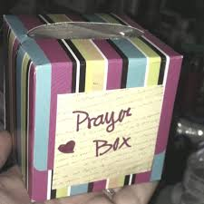

Pray:
Dear God
We want to pray for people who are sick in hospital or at home We pray especially for those who are unwell because of COVID – 19. May they feel Your power of healing through the care of doctors and nurses. Please take away the fear any fear. We pray for people who are lonely at home and those who are sad. Please be with the homeless and may they have enough food. Help us to be kind seek out opportunities to serve others and show them your love. Amen
Do
- Could you donate to a food bank?
Snowflakes
Snowflakes are fragile too. Make a snowflake and send it to someone you know who is self-isolating. Or pin it up to remember to pray.
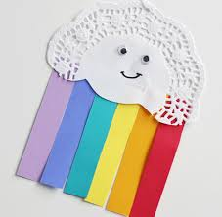

5. People who help us
There are lots of people at the minute still working to help.
- Where do you get your food from? What people work there?
- Who makes the medical supplies?
- Who keeps us safe?
- Who is working on new drugs and vaccines?
We want to pray for safety for all of the shop workers, emergency services and factory workers.
Collage – Make a poster from food packages, magazines or catalogues. Thank God that we have everything we need.
Pray
Dear God
Thank you for all the people who work in pharmacies and shops. Keep them safe and help them to cope with the extra pressure of delivery, stocking shelves and selling. We also pray for police, and emergency services, for delivery men, postmen and others who are working hard to keep us safe. Thank you for people working in factories making medical equipment and food products. Thank you for farmers. Please keep all key workers safe and help them to turn to you to help them in difficult times. Amen
Do
Prayer map: Make a map of your neighbourhood to help you pray for the people in it.
You will need: wool; ribbon; junk cardboard boxes; pens; coloured paper; card; markers.
- Starting with your home, make a map of your neighbourhood stretching out the string, wool or ribbons to be roads and rivers, and using boxes and cardboard shapes to be buildings (schools, offices, hospitals, shops, farms and so on) or geographical features (hills, ponds, parks and so on).
- Talk about the people who live around you and pray for them to come to know Jesus, either by placing your hand on the place on the map where they live or work. Use simple words, like ‘Please help X know Jesus’ love’.
6. People around the world
There are people all over the world who are affected by this virus, like you they are staying at home and can’t go to school, church or games. Print a map of the world. Look at where all the countries are. Some of the poorer countries are worst hit by this virus as they do not have enough medical supplies.
Pray for our missionaries who are still serving God in faraway lands. Pray they will be kept safe. Pray for the poorer parts of our world.
Bubble/balloon prayers
If you have any bubbles you could blow some (or use a balloon). When a bubble floats to the ground, this is a moment to pray a ‘help’ prayer for our world and when a bubble floats up into the air, they say a ‘thank you’ prayer e.g. thank you God for people who serve you all over the world.
Animal hunt
Lots of poorer countries are worst hit by the effects of COVID 19. Many of these countries, like African, Asian countries have lots of wild animals. Draw pictures of different animals or make with playdoh animals and pray for the country. Find out facts about the country
Dear God
We want to pray for those who are sick all over the world, particular those in faraway countries who might not have very good medical care. Lord protect them and be ever present with them. We pray for those countries that have been hardest hit by the virus so far that they will know your presence. We pray for our missionaries who are showing your love in faraway lands. Be with them as they may be worried or scared, and we pray for their families who may be at home. Amen
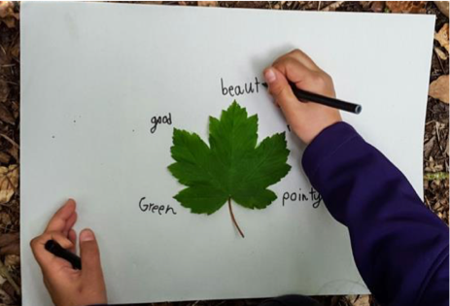
Activity
The natural world around us is amazing and beautiful! If you have a garden, go out and find a leaf that you like – remember, no two leaves are alike – the one you’ve chosen is unique!
Stick your leaf in the middle of your piece of paper, then draw or write things that you’re grateful for in the world. It’s important to be grateful.
If you want to, you can draw or write these things as a prayer.
7. Our churches
- Thank God that we can still keep connected to our church through the internet.
- Pray that God would use this time to reach people who don’t yet follow Him. Pray that we can be bold and ask friends to watch some Bible stories onliine or a parents and toddlers group
- Pray that the church would be a calming presence in this anxious time.
- Pray for those who are lonely and may the church reach out and show them Jesus love.

Skittle painting prayer.
You will need: a bag of Skittles; a plate; hot water (not hot enough to scald, but hot enough to make the colour run).
- Choose a Skittle for each person you are praying for.
- Choose people from your church and your minister.
- Arrange the Skittles on the plate. Alternatively, you might want to make the initial letter of your prayer person’s name out of Skittles.
- Pour some hot water on to the plate to cover its surface. Pour it carefully so that the Skittles stay in place.
- Wait and the Skittles will gradually release their colour. As the colour is released, pray that Jesus will surround the people you are praying for with his love.

Here’s a photo of my skittle prayer

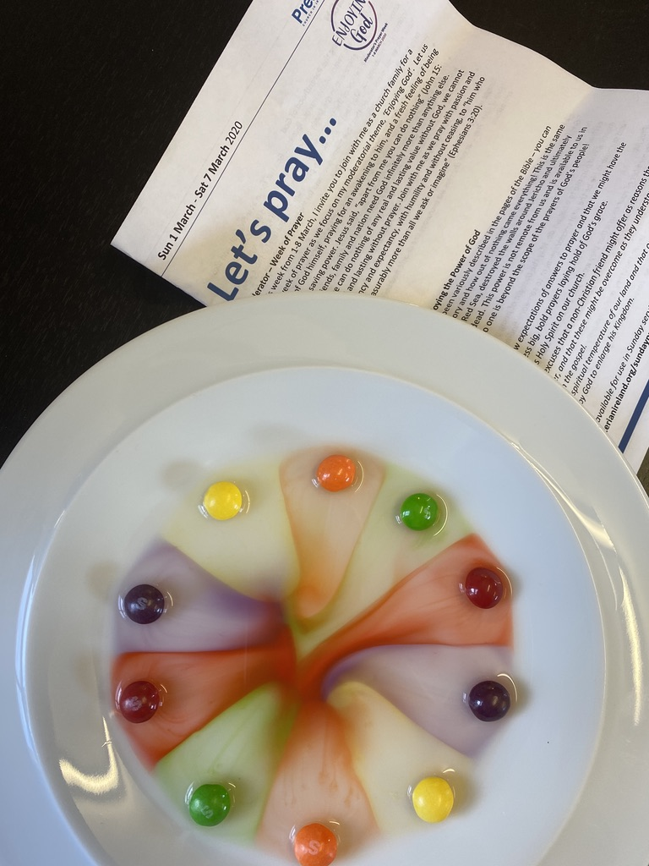
Pray
Dear Father God
Pray: Thank you for our minister and ministry team. We thank you for how they have spent time in putting services and resources online so that we can still worship together on Sunday. Be with them in all the planning and help guide them in teaching us from your word.

Lord Jesus,
We pray for everyone who belongs to our church If they are worried, tired or lonely we pray that you would help them to know you love them. If they are happy, we pray that they would give you thanks and praise you with joy. We pray that everyone in church would listen for your voice
Help us all to listen to your teaching so that we may love and serve you better. Amen
Do
Play a measuring game/bake some buns.
- Measure different things – your height, the weight of an apple, how long it takes to hop to the side of the room, the distance from your table to the sink etc.
- Or do it in teams - Each team needs a ruler and a list of 5 things to measure e.g. table, window, Bible etc. The first team with the correct answers will be the winner.
- Alternatively bake some buns, with lots of measuring out.
There is one thing, that is impossible to measure.
It is God's Love.
For God so loved the world that he gave his one and only Son, that whoever believes in him shall not perish but have eternal life. John 3:16 (NIV)
Pray
Thank you, Father, for loving us, for creating us, and providing for us a way to be forgiven of our sins. You showed us the greatest love of all by sending your son to die on the cross so that we might have eternal life. Forgive us when we don't trust you to take care of our needs and when we forget to be thankful for the love you have shown us. Amen.

What can you do for God?
- You can continue to pray!
- You can read your Bible and listen to church online
- You can be helpful and kind!
- You can smile and encourage others!
- You can enjoy God!

I hope that you will.

William

