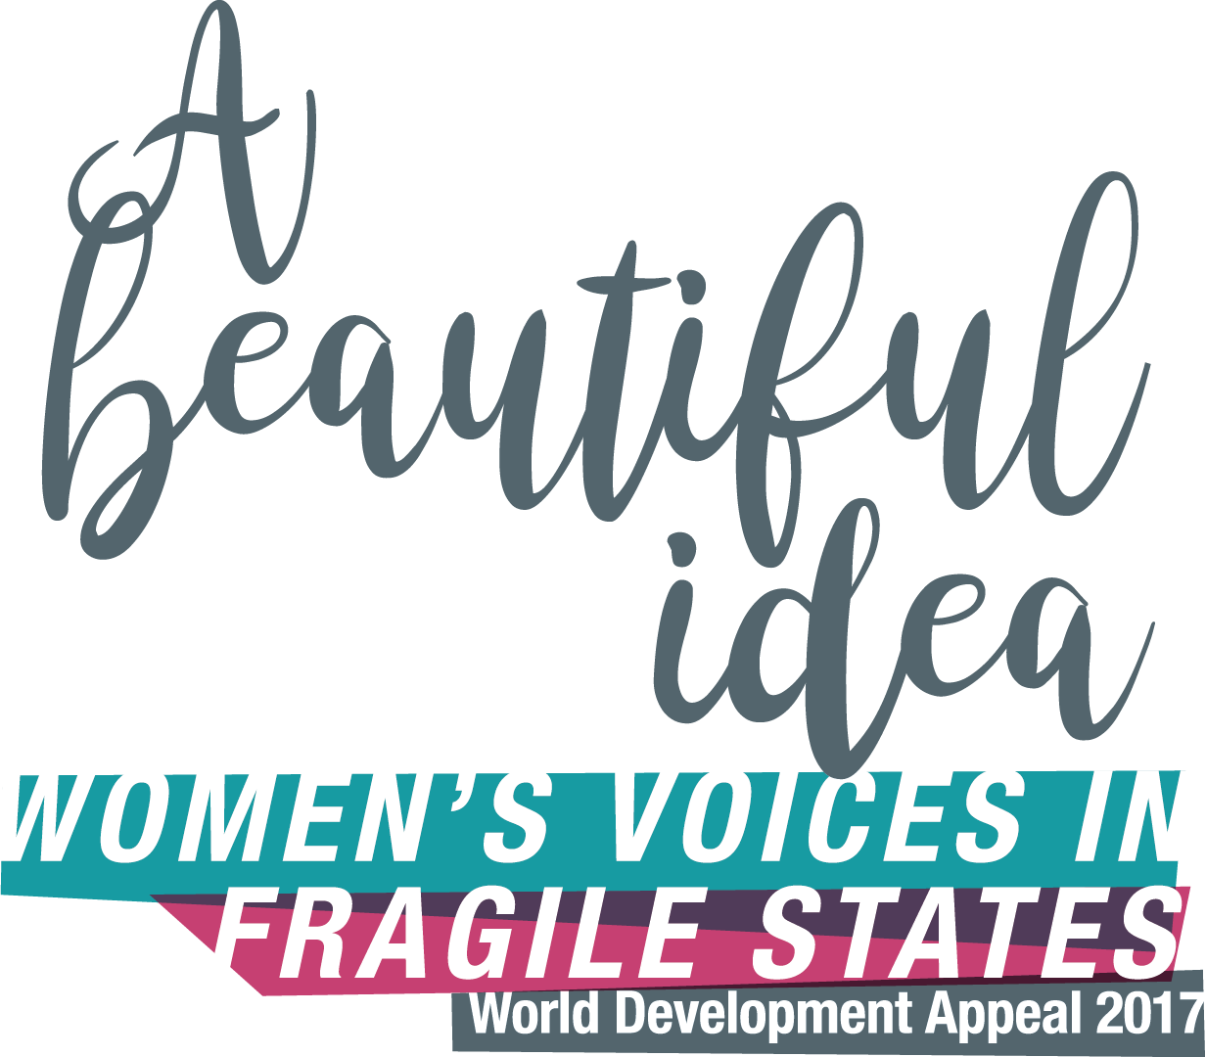

Theological Reflections

‘Poverty has a woman’s face.’ Slogans never tell the whole story, but they often tell an important part of the story. And one of the stark truths we need to grasp when we listen to the experience of our partners around the world is that if you are a woman, you are more likely to be poor.

The causes of poverty are many: poor access to clean water, the effects of climate change on weather and agricultural practices, HIV infection and other preventable illnesses, and land dispossession, among many others. But because of the way most societies are structured, their most sustained impact is on the lives of women.

Furthermore, women’s lives, as well as those of men, are made more difficult again when the civil society around them is fragile. Life becomes more chaotic and unpredictable. The basic structures people rely on as they go about their daily lives are simply not there. And in this stressful situation, women often suffer yet again, as the incidence of sexual and gender based violence increases, putting both women and children at risk.

The term ‘gender justice’ refers to the work of building relationships between women and men which are justly structured, that is, in which both are equally valued, both are empowered to effect change for themselves and on behalf of others, and both are able to seek and to embrace the human rights and civic responsibilities to which they are entitled. It is part of the work of sustainable development to which we are committed through the World Development Appeal. And yet as our Tearfund and Christian Aid partners remind us each year, gender justice is a work in progress, even close to home.

Those of us who approach the work of sustainable development from a Christian perspective are sadly aware that churches have sometimes remained silent in the face of women’s suffering. Christian voices have also not infrequently added to that suffering by belittling it, or by seeking to limit the hearing of women’s voices, or by teaching acceptance of the status quo.

And yet we also know that we have a strong foundations for the work of gender justice in this same biblical tradition. The sheer exuberance of the creation stories in the Book of Genesis implies among many other things that the diversity found among women and men in community should function as a source of celebration and delight, and not as a source of fear or a means of oppression, whether for women or for men.

The word for the ‘helper’ (NRSV,NIV) or ‘companion’ (NET Bible) made by the Lord God for the first human being (Genesis 2.18 ff) is the same Hebrew word which often refers to God our ‘help’ (see Exodus 18.4, for example). So there can hardly be a connotation of secondary status. The description of this companion as ‘fitting’ or ‘corresponding’, however, removes the description from the realm of the inferior/superior and roots it in a sense of equality and mutuality. The isolation of the first human being is addressed through the creation of this companion, with whom a human identity is shared.
Furthermore, up until this moment, every living thing that the Lord God has created has been formed from the earth. Now, however, the Lord God literally builds what is taken from the side of one human being into another human being, a woman. And the man’s first response is to recognise not their difference but their kinship and equality. She is “bone of my bones and flesh of my flesh” (Genesis 2.23), he exclaims.

They are two living human creatures, but they are one flesh, which suggests solidarity, mutuality, equality. The focus is not on what is ‘opposite’, but on the companionable distinction of the two, who nevertheless experience a unity which is first of all an equality of bone and flesh.

The 2017 Appeal turns its focus to partners working in the dangerous and difficult context of the Democratic Republic of Congo. Here they are addressing issues of gender justice as an important foundation for the peacebuilding and community development initiatives needed at every level of their troubled and fragile society.

The main film produced for the Appeal tells the story of a women’s self-help initiative, focused on maternal and neonatal health. The women of Zumbe have set up a travel fund which now provides for transport to hospital when a pregnant woman approaching her due date experiences complications. Like the midwives of the Hebrew people in Exodus 1, these women became tired of seeing the lives of mothers, and those of their babies, being placed at risk, and took their own initiative in defiance of the status quo. The market garden which they now cultivate, thanks to additional help they have received from Tearfund through local partner Action Entraide, ensures that the travel fund is able to meet their needs in full.

In the second film, for adults only, Hope tells her story of being kidnapped and gang raped, and then recounts something of the hard yet life-affirming journey she has made in the ten years since. Like the Samaritan woman, in the presence of the living Christ she finds a way to turn her own particular circumstances into a source of theological reflection, and comes to recognise that the telling of her story, and the sharing of her continuing reflections upon it, is now her calling.

The 2017 Appeal lifts up the voices of Hope and the women of Zumbe in order to highlight the need to put gender justice at the heart of sustainable development. We do so in response to our biblical calling, which is to do justice but also to live in profound awareness that for all our created diversity, we are one in Christ, and share the one flesh of humanity which was also his.

