May 2024
Special Work in West Belfast –
Rev David Moore
For more information on PCI’s work in West Belfast, go to www.presbyterianireland.org/mission or contact: Presbyterian Church in Ireland, Mission Department on +44(0)28 9032 2284| mission@presbyterianireland.org
Registered Charity in Northern Ireland (NIC104483) | Registered Charity in Republic of Ireland (20015695)

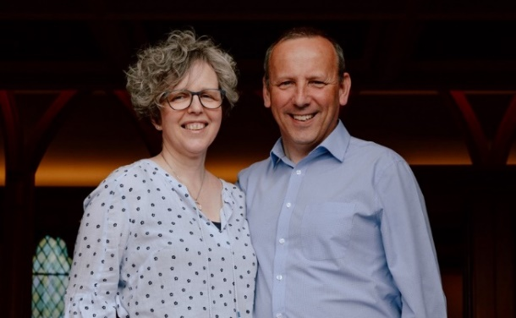
Since our last prayer letter, we held the second of our three worship services planned for this academic year. We were delighted that 50 people attended our Palm Sunday service, with a third of them being from the local area. You can see photos of the event on our Facebook and Instagram pages (search for An Tionólann).
We value your prayers for the third and final service in May, after which we will assess how this pilot scheme has worked and decide what steps to take from September onwards. Please join us in praying for the beginning of some form of regular worship in the area.
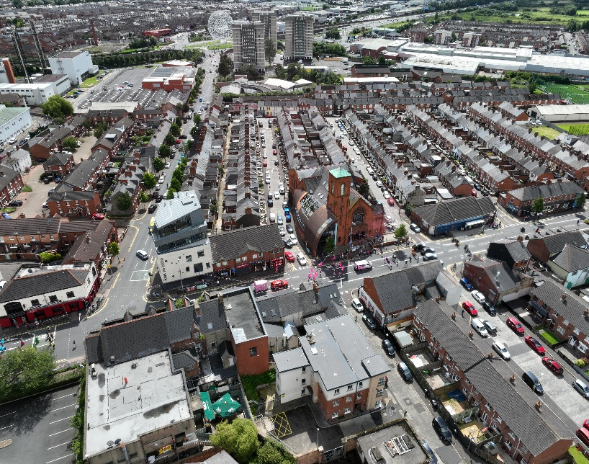
Some people have asked us where exactly is it that we work. While all of West Belfast is designated a special missional area the photograph included below gives you an idea of where we have been based for most of our activities. Towards the top of the picture, you will see the sculpture officially known as “Rise” which sits on the roundabout below which the Westlink joins the M1. The road leading directly from it is Broadway, which borders the RVH (on the left).
Broadway ends at a T-Junction with the Falls Road. On the right-hand side of that junction stands a white building with a grey roof. This is Áras na bhFál where were hold our weekly Bible Studies on the top floor.

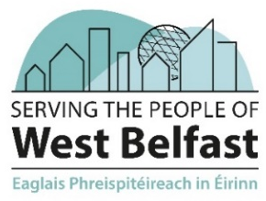

One block to the right of this is a large brick building, which looks like a church. Indeed, it used to be the home of Broadway Presbyterian Church, but which is now Cultúrlann MacAdam O’Fiach, an Irish language cultural centre. The rounded extension on the lefthand side of this building is a gallery space. This is where we attempt to learn Irish each week, but also where our services have been held.
I hope this will help you picture where we mean when we mention these locations. Please pray for the following items over the coming months:
- A talk on the Bible and Irish on 17th May in the gallery space in Cultúrlann given by our friend John Duffy, Colin Glen Christian Fellowship
- Our next worship service on Sunday 26th May
- For Cillian MacNamara who will be working with us as our Summer Assistant from the beginning of June.
- The Albert Street exhibition being shown in Assembly Buildings during the General Assembly, 20-22 June

