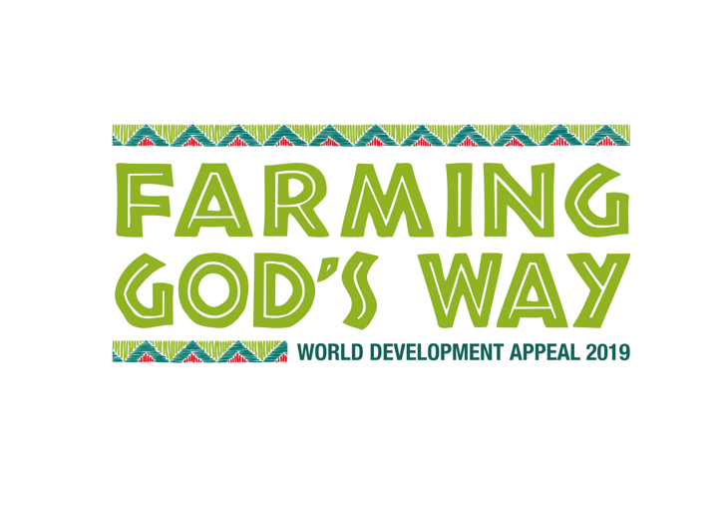



**Background on Mozambique**

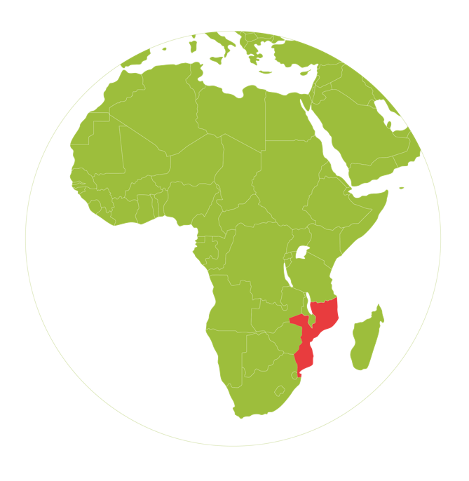

Mozambique was formed as a Portuguese colony. In 1975, after over ten years of war, Mozambique gained independence. The country then suffered years of civil war between two political groups, RENAMO and FREELIMO, from 1977-1992. After nearly 20 years of peace, in 2013, RENAMO declared it was withdrawing from the 1992 peace agreement. From 2012 to 2016 RENAMO fighters retreated to the bush causing main roads to be accessible only by armed convoy and 11,000 people were displaced. In 2017 a truce was agreed between RENAMO and FREELIMO and another peace deal signed in 2018. October 2019 will see a general election which Mozambicans hope will deliver long term peace.

In the Northern province of Mozambique, Cabo Delgado, Al Shabaab militants are operating, making it very difficult for NGOs to carry out their work there. Tearfund has been working in Mozambique for 30 years.

The capital is Maputo in the South and there are ten provinces. Currently, 80% of Mozambicans live on less than $2 a day, and it is ranked 180 out of 188 on the UN Human Development Index. Over half of Mozambicans don’t have access to clean water. 56% of the population is Christian with Evangelical Christians the fastest-growing religious group.

As a country lying on the tropics, bordered by the Indian Ocean, Mozambique is very vulnerable to natural disasters such as floods, cyclones and droughts. Currently, areas of the country are suffering severe drought while still recovering from the impact of Cyclone Idai. Food security is a big issue against the backdrop of these natural disasters. Tearfund is working to build in disaster risk reduction and greater resilience to all its programmes in Mozambique.

Tearfund has a history of HIV/Aids Work in Mozambique, especially in the central provinces which act as a transport corridor from the port town, Beira, to much of south-eastern Africa. In recent years Tearfund has focused on building the capacity across our Mozambican partners to deliver Church Community Transformation work including both Umoja and contextualised versions of Umoja. In March 2019 Tearfund appointed a new country director, Edgar Jone. Edgar’s first challenge was to coordinate our Cyclone Idai response through partners on the ground.

Tearfund’s partner, the Ecumenical Committee for Social Development (CEDES), was formed through church denominations coming together to support and repatriate refugees from the civil war. Once this work was completed, they moved into undertaking development work and improving infrastructure in 1998. CEDES is delivering both Tearfund’s disaster response to Cyclone Idai as well as doing long-term development work. In the latter, CEDES utilises Umoja and Self-Help Groups as part of their Church Mobilisation programme with local churches, and also contextualised Umoja with farming co-operatives incorporating conservation agriculture techniques and promoting Self Help Groups. Great emphasis is put on using locally available resources ensuring beneficiaries are self-sufficient.

**Conservation Farming Principles**

Co-operatives are formed from the local community. They share one large plot of land broken down into several beds for each person. Every time they meet together, they carry out a Bible study and often participate in a savings and loans group (Self Help Group). In addition to this, CEDES staff provide training on conservation farming techniques and supply some seeds to help the co-operatives farm. The produce that the co-operative grows is then used by the families involved. It can also be sold in the market or to people who visit the farms to buy food, generating income. Conservation farming has enabled the communities to grow food outside of the traditional growing season in a semi-arid climate, transforming sandy ground to rich earth where crops grow quicker and produce higher yields.

Increased crop yields come from:

1. Maintaining a covering of mulch, or ‘God’s blanket’, made from peanut leaves, which are high in zinc, and not burning last harvest’s plant debris. This maintains water content in the soil (especially useful when rains are poor) and reduces soil erosion.
2. No ploughing - it is expensive. Farmers are shown how to preserve the natural soil structure so it absorbs water better. Instead of ploughing, they dig basins or beds for planting seeds.
3. Planting crops with precise spacings to give plants the best chance to survive, and providing them with nutrition using natural fertilizer from chickens or bats. Crop rotation also cuts down on pests without the use of harmful chemicals.
4. Regular weeding when the seedlings planted are still small - this saves time and energy in the long run.
5. Watering twice a day using water from hand dug wells on site

These principles are radically different from the western techniques farmers have been using for generations. The tools needed are so simple: a hoe, a measuring stick, measuring string, fertiliser or manure, and seed. Because of this, it is often met with scepticism, yet it is ecologically friendly, and it benefits the farmers. When the principles are applied well, crop yields will increase, and actually keep improving over the years meaning whole families who are trained in this method and follow the principles well are released from the cycle of poverty and can survive the challenges of climate change.