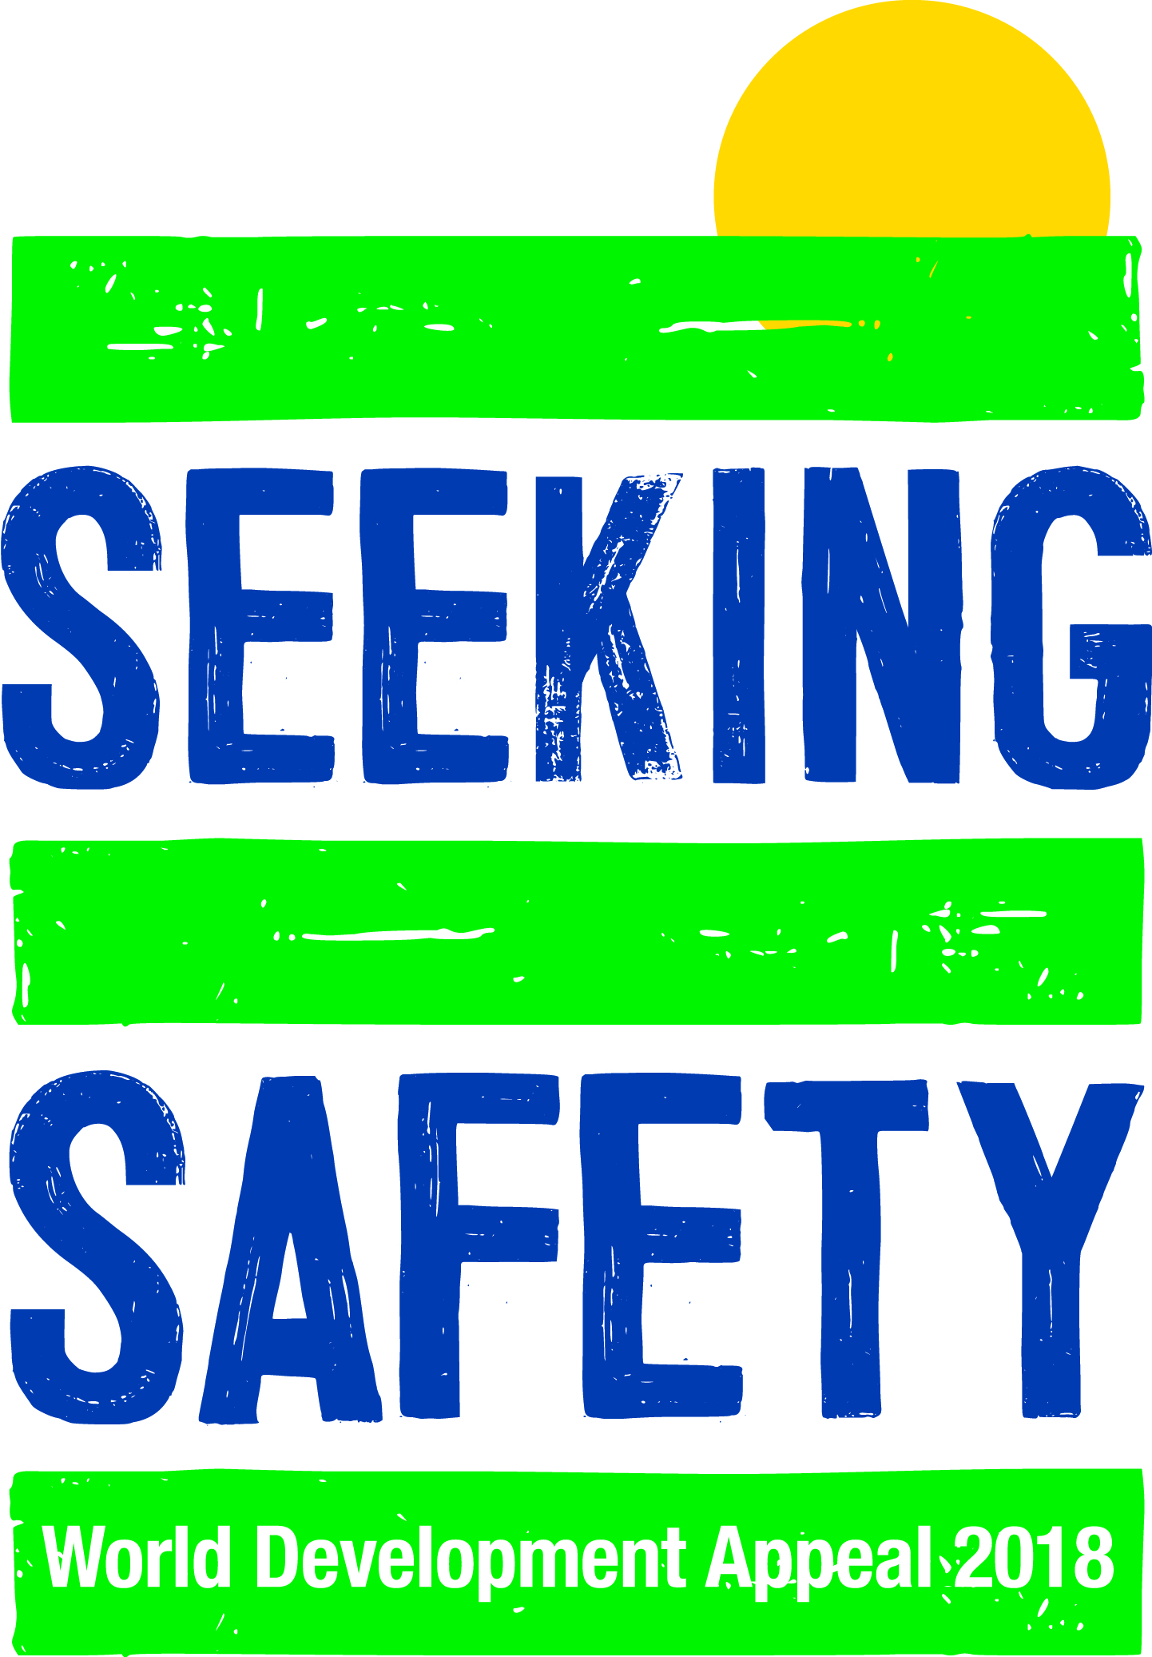
COUNTRY CONTEXT: BRAZIL
With approximately 210 million people, Brazil has the largest population of Latin America and the Caribbean with expressive presence of Afro-descendent and indigenous people, spread across five geo-political regions in 27 states. The largest exporter in the world of many commodities (coffee, soybeans and beef), Brazil is a middle-income country that nevertheless remains as a paradox. The impressive wealth and beauty hide stark inequalities, and a worsening of socio-economic situation. According to the World Bank, between 2.5 and 3.6 million people fell below the poverty line in 2017. An unprecedented crisis since 2015 and widespread corruption are severely affecting the most vulnerable groups, who are suffering from setbacks to their rights and large cuts in social policies, bringing back poverty and even hunger.
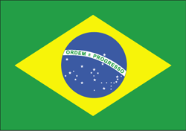
Violence and inequality: Brazil is a very dangerous place to be a woman or a LGBTI person: almost 5000 women are murdered every year, and every 25 hours one LGBTI person is killed. The ruthless scramble for its natural wealth made Brazil the world’s deadliest country for environmental defenders: in 2017, 63 people were murdered in conflicts related to the defence of the environment and its inhabitants – 49 were in the Amazon. The increasing pressure on natural resources by mining companies, agribusiness, hydroelectric dams, and illegal logging are key drivers of violence and displacement especially in the Amazon. That trend is expected to continue in 2018 with increasing land conflicts and escalating tensions related to the coming elections. This is a sad reflection on a country which only a few years ago was known for its leadership on global social and environmental issues.
Inequality remains the main issue in the country but it has new dynamics with outbreaks of violence and the shrinking of democracy. The current political instability in the country is unlikely to cease in a near to intermediate future.
Brazil has a strongly religious population, in which Christians are the large majority. Faith plays an important role in shaping notions of solidarity and justice. The presence of churches as spaces for civil society mobilization has contributed to the emergence of social movements and NGOs as actors in the public arena. Moreover, churches represent legitimate voices in the defence of the poorest and most vulnerable populations in the current context of growing violence and inequality, as the example of the Noeli dos Santos safe house illustrates.
The state in which the town of Ariquemes is based is Rondonia, just on the edge of the main Amazonia region and near to the border of Bolivia.

