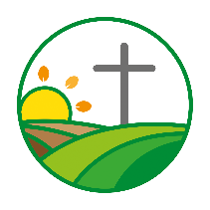
Prayer update
May 2024
Kenny Hanna, PCI Rural Chaplain

Livestock Markets and Farmers
Please pray for farmers and farming families, for whom the many months of wet weather have brought hardship. Some crops were lost in the Autumn - they could not be harvested. With Spring crops being considerably behind-time in getting planted (in some cases, farmers will have to scale back, or not plant at all). Cattle had to be housed in the Autumn earlier than usual and are being turned out to grass in the Spring later than normal. All this leads to financial pressure and mental health concerns. Please pray that farmers will feel able to seek support and that rural chaplaincy, and others, will be able to help.

Give thanks to God for, at the time of writing, an encouraging window of dry weather. Thus enabling cattle to be turned out from their Winter housing, onto the grass, while some Spring crops are in the process of being planted, and silage, to provide Winter feed, is beginning to be harvested.
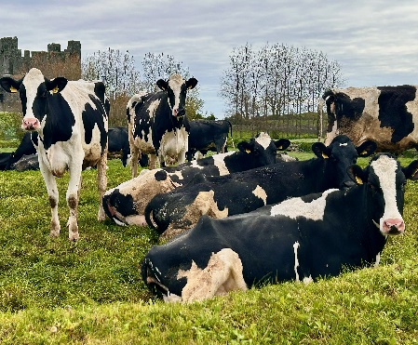
Speaking Engagements - (Including Local Churches)
- Friday 12th May – Anaghlone and Garvaghy
- Sunday 26th May – 2nd Saintfield
Please remember the Rural Chaplaincy Panel, meeting Wednesday 1st May. May God guide our discussions. Thank God for the many opportunities He is opening up for the work of rural chaplaincy and ask Him to give us godly wisdom about how best to take them.

Night of Training and Prayer for the stand at Saintfield Show – Wednesday 22nd May. Please pray for lots of team members to staff the stands at all the Shows we are involved in – as well as Saintfield, we have stands at Armagh, Castlewellan, Lurgan and Newry Shows. May the times of training and prayer be filled with God’s blessing and may each person involved be equipped to be a godly and attractive witness for Jesus.

At the General Assembly, a report will be given about the future of rural chaplaincy in PCI. Please join with us in praying that God will enable us to “discern what is the will of God, what is good and acceptable and perfect” (Romans 12:2).

Dairy cows out at grass recently

Other Opportunities and Needs
Thursday evening 9th May – Hilltown Hotel Bible Study. God has placed us right in the centre of Hilltown village. Please pray that new people will continue to join us, feel at home and respond to Jesus’ welcome

Wednesday 15th May – Saturday 18th May – Balmoral Show. NI’s biggest agri-event, with an annual attendance of some 100,000 people. Please remember Dromore Presbytery, as they run a stand at the Show. Rural Chaplaincy will also be attending events and meeting people throughout the 4 days. The Moderator and Mrs Mawhinney will visit the Show on Wednesday, spending time on the Dromore Presbytery stand and accompanying me in meetings with farm support agencies and others. Please pray, between us all, and alongside many other Christians involved at Balmoral, that we will have many opportunities to lovingly point people to Jesus.
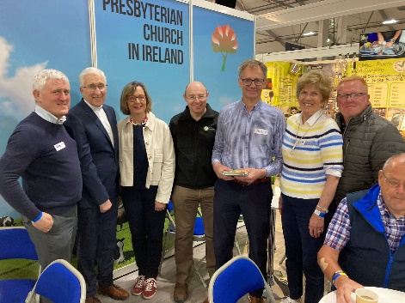
Wednesday 29th May - Kilcoo Bible Study. Please pray that relationships within the group will continue to grow and deepen and that God will be at work, drawing attendees to a clear and living relationship with Jesus.

Dromore Presbytery stand last year

