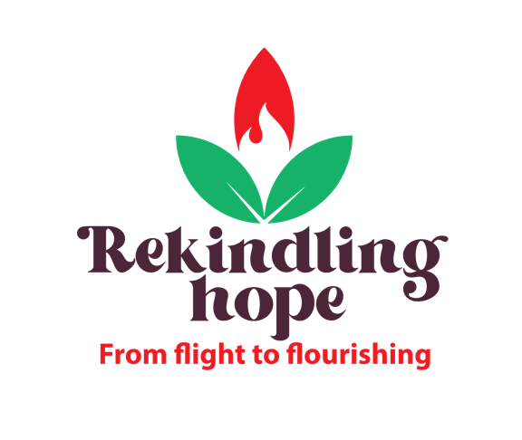

World Development Appeal 2022
Suggested hymns

Brother Sister Let Me Serve You
I The Lord of Sea & Sky
There is a Hope
He Will Hold Me Fast https://youtu.be/936BapRFHaQ
Because He Lives
Great Is Thy Faithfulness
The Lord Is My Shepherd https://youtu.be/pN4tPkX0MG0
Turn Your Eyes Upon Jesus https://youtu.be/F2tKVqZZiI4
10,000 Reasons (Bless The Lord O My Soul)
Come Thou Fount of Every Blessing
Ancient Of Days https://youtu.be/tUp02T4gvm0

Jesus Loves The Little Children
Great Big Family Of God - https://youtu.be/smkYUzrgD7A
He's Got The Whole World In His Hands

