GROWING IN FRUITFULNESS
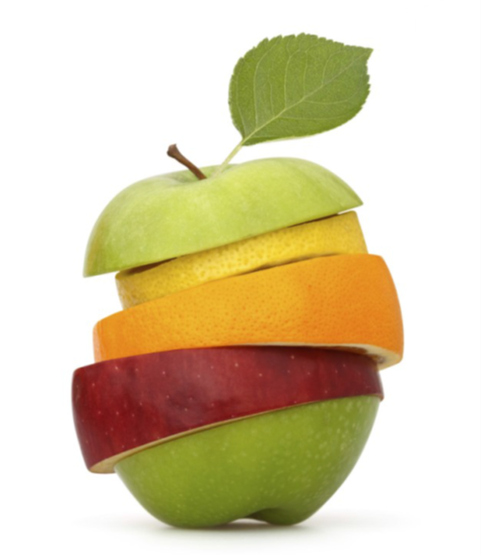
The Vision | John 15 v. 1-17 (New International Version)

Listen and pay attention to the images as the passage is read. Which picture illustrating John 15 did you find most striking? Why?

¹ ‘I am the true vine, and my Father is the gardener. ² He cuts off every branch in me that bears no fruit, while every branch that does bear fruit he prunes^{[a]} so that it will be even more fruitful. ³ You are already clean because of the word I have spoken to you. ⁴ Remain in me, as I also remain in you. No branch can bear fruit by itself; it must remain in the vine. Neither can you bear fruit unless you remain in me.

⁵ ‘I am the vine; you are the branches. If you remain in me and I in you, you will bear much fruit; apart from me you can do nothing. ⁶ If you do not remain in me, you are like a branch that is thrown away and withers; such branches are picked up, thrown into the fire and burned. ⁷ If you remain in me and my words remain in you, ask whatever you wish, and it will be done for you. ⁸ This is to my Father’s glory, that you bear much fruit, showing yourselves to be my disciples.

⁹ ‘As the Father has loved me, so have I loved you. Now remain in my love. ¹⁰ If you keep my commands, you will remain in my love, just as I have kept my Father’s commands and remain in his love. ¹¹ I have told you this so that my joy may be in you and that your joy may be complete. ¹² My command is this: love each other as I have loved you. ¹³ Greater love has no one than this: to lay down one’s life for one’s friends. ¹⁴ You are my friends if you do what I command. ¹⁵ I no longer call you servants, because a servant does not know his master’s business. Instead, I have called you friends, for everything that I learned from my Father I have made known to you. ¹⁶ You did not choose me, but I chose you and appointed you so that you might go and bear fruit – fruit that will last – and so that whatever you ask in my name the Father will give you. ¹⁷ This is my command: love each other.

Fruitfulness in challenging times for the Church: > < =
More than merely faithfulness to the way we have always done things in a changing world;
Often less than success in the eyes of a superficial world;
But always the growth of His Kingdom that is not of this world.

Unpacking the vision a bit more… back into John 15
Picture – Church: It’s a field, not a factory v.1
Pain – Growth: It involves pruning v.2
Promise – Expectation: Look for the fruit v.5
Prayer – Ask: Fruit is given from above v.7
Purpose – Him: It’s not about us v.8
Pathway – Follow: It’s modelled by Jesus v.9-15
Privilege – Appointed: Right here, right now v.16

Surveying the landscape of your congregational life and witness: Fruitful or unfruitful?

AS A GROUP: Discuss the area of greatest unfruitfulness in your congregation’s life and witness
AS A GROUP: Discuss the area of greatest fruitfulness in your congregation’s life and witness
Growing the fruitfulness conversation in your congregation: Three key seasons
Season 1 SEEDING: Introduce God’s vision of fruitfulness to your members
Season 2 RIPENING: Identify two areas in which you want to prioritise growth
Season 3 HARVESTING: Implement the development of habits and ways of doing things which, under God, work the ground and sow the seed for a local expression of fruitfulness
A conversation that is yours to grow: Know, plan, pace your own particular journey toward greater fruitfulness

Resources for growing the fruitfulness conversation in your congregation
All resources available at https://www.presbyterianireland.org/fruitfulcongregations

Season 1 SEEDING: Introduce God’s vision of fruitfulness to your members
– Web-based, flexible launch resource and material for 6 follow up sessions

Season 2 RIPENING: Identify two areas in which you want to prioritise growth
- A second evening gathering to take stock February/March 2017
- A discussion tool to choose two areas in which to work for use in Kirk Session, working groups or whole congregation settings

Season 3 HARVESTING: Implement the development of habits and ways of doing things which, under God, work the ground and sow the seed for a local expression of fruitfulness
– Signposting resources, stories and ideas

In every season WATERING: Interceding in prayer
– Fruitful Congregations Prayer Journey www.presbyterianireland.org/Prayer/Prayer-Journey or copy from CLW office
A closer look at resources for Season 1 - SEEDING: Introduce God’s vision of fruitfulness to your members
AS A GROUP: Discuss how best you could seed the vision of fruitfulness in your congregation?

A look ahead to seasons 2 and 3 - RIPENING and HARVESTING
