Ripening the conversation: Identifying priority areas

Option 1: Fruit Counter

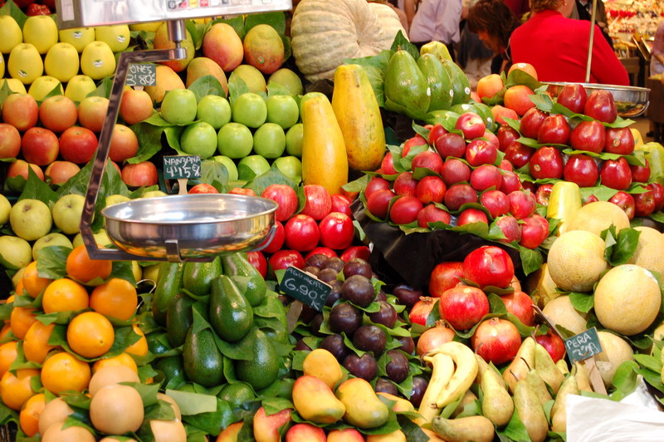

Best for a congregation:
- that likes a structured, scientific, organised, approach
- that is confident in verbally expressing itself
- that is able to cope with a variety of opinions
- that is secure enough to acknowledge weaknesses
- that is able to see a big picture emerging

Involves a large group discussion, or small group discussion, with feedback.

Uses the Fruitful and Unfruitful Congregation hexagon diagrams to invite individual choices. Results in a visual wall display, leading to discussion and capturing ideas for simple next steps on a flipchart.

All tools available as downloads at https://www.presbyterianireland.org/fruitfulcongregations

Introduce the ripening season
- Use the Introducing the Hexagons Powerpoint with as many of the congregation as you can gather.
- Spend some time using the Fruitful Congregation Prayer.

Recognising our congregation’s fruitfulness
- Download the materials from the document Option 1: Photocopiable Fruitful Congregations Hexagons and photocopy a set for each participant
- Give out the six hexagons from the Fruitful Congregations diagram to each person.
- Invite them to choose one which represents what they discern is an existing strength of the congregation to build on and display it on a wall.
- Arrange the hexagons chosen, like with like.

Recognising our congregation’s unfruitfulness
- Download the materials from the document Option 1: Photocopiable Unfruitful Congregations Hexagons and photocopy a set for each participant
- Give out the six hexagons from the Unfruitful Congregations diagram to each person.
- Invite them to choose one which represents what they discern is an existing weakness of the congregation to address and display it on a wall.
- Arrange the hexagons chosen like with like.

Discussing and discerning
Discuss the pattern that has emerged as a whole group, or in smaller groups. What do you find:-
- Energising (we have been excited by this)
- Surprising (we didn’t see that coming)
- Transforming (this might begin to change how we think and what we do)
- Disconcerting (this is really rocking our boat)
- Yourself having to come to grips with... (this is an issue we are finding particularly challenging)

Identifying two areas in which to prioritise developing growth in the next season of life and witness

As a whole group, or in smaller groups, discuss the two areas identified for developing growth. In both cases ask:-

- What areas of existing church life could offer fertile soil for cultivating fruitfulness?
- What hard ground might need broken up?
- What new soil might need to be turned over?

Capture this on a flipchart or on large pieces of paper given out to each small group.

Identify simple next steps for both priority areas.
Capture this on a flipchart or on large pieces of paper given out to each small group.

Water with Prayer
Pray about what has emerged.

Ripening the conversation: Identifying priority areas

Option 2: Hanging Fruit

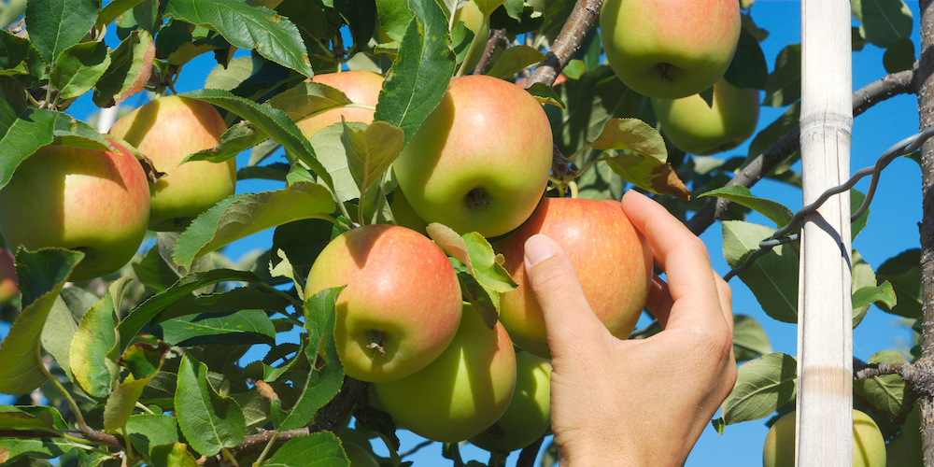

Best for a congregation:
- that is less confident about verbally expressing itself
- that will find a variety of opinions relationally awkward
- that will not easily cope with being confronted with the Unfruitful Congregation analysis
- that is not used to pulling together overall strategy

Involves a group working less verbally and more visually with light facilitation.

Uses the Fruitful Congregation hexagon diagrams displayed on a wall. Post-its allow participants to express their views more individually and privately, but enable the building of an overall picture. Leads to identifying areas of growth, gaps and overlaps in congregational activities. Limited element of discussion. Post-it vote chooses two areas to prioritise and further written contributions suggest a co-ordinated way forward and ideas for simple next steps. This will take more time. It may be best completed over two sessions.

All tools available as downloads at https://www.presbyterianireland.org/fruitfulcongregations

Introduce the ripening season
- Use the Introducing the Hexagons Powerpoint with as many of the congregation as you can gather.
- Spend some time using the Fruitful Congregation Prayer.

Using the fruitfulness diagram to identify growth, gaps and overlaps

- Download the materials from the document Option 2: Photocopiable Headers Fruitful Congregations Hexagons and photocopy a set to display as heading on the wall.
- Display the six hexagons from the Fruitful Congregations diagram on the wall.
- Using post-its, invite participants to write the names of existing organisations or activities which contribute to the congregation’s fruitfulness and stick them under each hexagon.
- Note were there are areas of significant activity and growth, gaps in activity and growth and overlaps in the arrangement of activities.

Discussing and discerning
Discuss the pattern that has emerged as a whole group, or in smaller groups. What do you find:-
- Energising (we have been excited by this)
- Surprising (we didn’t see that coming)
- Transforming (this might begin to change how we think and what we do)
- Disconcerting (this is really rocking our boat)
- Yourself having to come to grips with (this is an issue we are finding particularly challenging)

Identifying two areas in which to prioritise developing growth in the next season of life and witness

Using post-its, invite participants to identify an area of strength to build on and an area of weakness to address and stick them on the wall under headings ‘Strength to Build On’ and ‘Weakness to Address’.

Identify simple next steps for both priority areas.

Using post-its invite participants to suggest ways to:

- Better co-ordinate the work of those organisations and activities that contribute to the strength to build on.
- Address the gap that has emerged as the priority weakness to be addressed, through existing organisations and activities and/or new initiatives

From these ideas, try to spot patterns that suggest simple next steps for both priority areas.

Capture this on a flipchart.

Water with Prayer
Pray about what has emerged.

Ripening the conversation: Identifying priority areas

Option 3: Soft Fruit

Best for a congregation:
- that might not be able to gather people together for a larger meeting
- that is less confident about expressing itself
- that has a lot of disjointed organisations and activities
- that will not easily cope with the Unfruitful Congregation analysis
- that is not used to pulling together overall strategy.
- that relies on a smaller group to set direction

Involves engaging organisation leaders and using a guiding group to facilitate organisations in telling the story of their work, collecting and evaluating feedback, spotting emerging patterns, identifying two priority areas and simple next steps. Deliverable in two ways as below.

- Gathering of organisation leaders to share their stories of what God is doing
- Visit to organisation leaders to gather their stories of what God is doing

Especially depends upon forming a guiding group that wields influence by commanding trust and can commend outcomes to gain ownership.

When using either means of delivery: Introduce the ripening season
- Bring together your congregational organization leaders and use the Introducing the Hexagons Powerpoint to explain the fruitfulness and unfruitfulness ideas.
- Spend some time using the Fruitful Congregation Prayer.

Gathering of Organisation leaders to share their stories of what God is doing
Have a ‘Fruitful Congregation Night’ in which organisations and activities of your congregation make a 10 minute presentation covering:-
- the particular area(s) of the Fruitful Congregation diagram to which they are aiming to contribute
- stories of fruitfulness they are seeing
- honest reflections on areas of unfruitfulness

Have a couple of people takes notes of what is emerging and feedback a general picture.

Visit to Organisation leaders to gather their stories of what God is doing
Have a ‘Fruitful Congregation’ team visit each organisational leadership and conduct the same exercise, feeding back the general picture.

Have a Guiding Group Meeting
Receive feedback and spot emerging patterns.

Identify simple next steps for both priority areas.

Water with Prayer
Pray about what has emerged.

