SOME RESOURCES
Presbyterian Church in Ireland ‘Roll of Honour 1914-1919’ available to buy from Amazon and on reference at the Presbyterian Historical Society and on their website. The data can also be searched online at a number of other websites.
Presbyterian Herald November 2014 article, ‘Sacrificial Service’ Rev. Dr. Victor Dobbin, former Chaplain General and Convenor of PCI Forces Committee. Also ‘Presbyterian Fallen Heroes’ by Herald Editorial.
In This Sign Conquer – Chaplains of the Presbyterian Church in Ireland in the Great War. Rev. Dr. Victor Dobbin. Booklet published by PCI.
Presbyterian Church ‘Blue Books’ during the War Years 1914-1919.
The Chaplain and the War. Rev. J. Esslemont Adams, a Church of Scotland Army Chaplain. Edinburgh, 1915.
The Royal British Legion have a ‘Remember the Battle of the Somme’ resource pack with DVD, including liturgical materials, available to order from their website www.rbl.org.uk/somme100

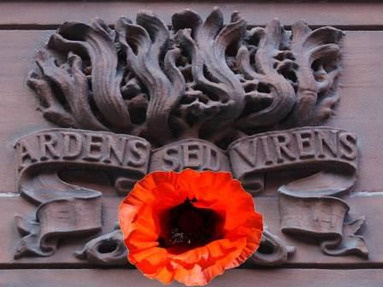

Irish Presbyterians
and the
First World War

Irish Presbyterians and the First
World War

2016 is a year of some significant Centenary Commemorations. The events of one hundred years ago have had an immense impact upon the shared narrative of our land, our Church and our identity, no matter where we are from on this island of Ireland and whether we recognise it or not.
Today, across this island, many people are searching for their roots and family history and as a result of the various centenary commemorations they are discovering for the first time that they had family members who served in the First World War, stories that may have gone untold for one reason or another. In our remembering may we do so in a spirit of togetherness and reconciliation for the sake of our shared future.
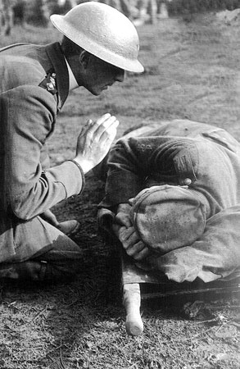
Many of these stories of men and women who served during World War One are intertwined with our Church as Presbyterians and our congregations where we worship, with many of their names engraved on memorials that don the walls of many our church buildings.
War was declared in the summer of 1914 and many thought that it would be over by Christmas. Little did they know that millions would die over the next 4 years in what became one of the deadliest conflicts in history.
For many people, the Battle of the Somme was the battle that above all symbolised the horrors of warfare in World War One.

element of the human experience and remembrance is at the heart of the Christian faith. We remember the greatest sacrifice of all, as the Lord Jesus Christ hung on the cross at Calvary, dying that we might live.
The Principal Chaplain, Rev. Dr. Simms visited Dublin, Londonderry, Ballymena and Belfast to report on the War efforts. Simms was accompanied by a Church of Scotland colleague Rev. J. Esslemont Adams, who wrote a short book at the end of the war entitled The Chaplain and the War, where he wrote this:
‘Many have to face death daily. Many die daily…They stand on the edge of the battlefield with bowed uncovered head whilst the chaplain prays, and go into battle with Psalms like the 23rd, 93rd, 103rd, and the 121st thrilling them. Their fortitude is fed on the faith they have in God the Father, Jesus Christ the Saviour, the Spirit of Christ in self-sacrifice, and the assurance of the life everlasting? What more need be said?’
A Prayer
Dear Heavenly Father,
We remember those at the Somme and in other conflicts who made the ultimate sacrifice for the freedoms we enjoy today. We think of how they have followed in the footsteps of your Son, our Saviour, Jesus Christ by laying down their lives for their friends. In our remembering we recall all who have suffered the ravages of war and, by your grace, we ask for that same self-giving spirit to be found in each one of us, leading us in the paths of peace and hope. We pray this in the name of the one who endured the cross and rose victorious over sin and death, Jesus Christ, our Lord.
Amen.

Reflections on the Great War and the peace that prevailed for a time afterward were written about in the newsletter of the Central Presbyterian Association that met at Assembly Buildings.

In Memoriam - OUR FALLEN HEROES.
Remember what they were, with thankful heart,
The bright, the brave, the tender, and the true.
Remember where they are -- from sin apart,
Present with God -- yet not estranged from you.
But never doubt that love, and love alone,
Removed our loved ones from this trial scene:
Nor idly dream, since they to God have gone,
Of what, had they been left, they might have been.
Central Presbyterian Association May 1917
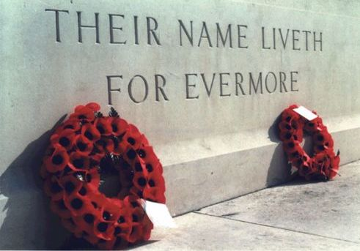
PEACE WITH VICTORY. ‘It is the Lord's doing; and it is marvellous in our eyes. Surely no words are better fitted to express our feelings of thanksgiving for the end of the horrible nightmare of four and a half years. So rapid beyond hope or dream has been our victory that we stand in amazement.
The news of November 11 seemed almost incredible, too good to be true. Of us it could be said, "they believed not for joy." But as we realise the glorious truth that the end has come, let us remember those to whom the joy bells bring the memory of the sacrifice whereby the triumph has been purchased. Our hearts, our prayers, our undying gratitude are with them. They with us can look up and say, "Peace at last! Thanks be unto God."’ Central Presbyterian Association December 1917.
While the bloom of the poppy fades away, our remembering of the events a hundred years ago must never die away. Remembrance is an essential
The memory of the Somme is dominated by one moment: 7.30am, or zero hour, on the 1st July 1916. It was a bright summer’s day, the sun well up, when the Officers sounded their whistles, and their men scrambled up ladders to get out of the trenches and into No Man’s Land.
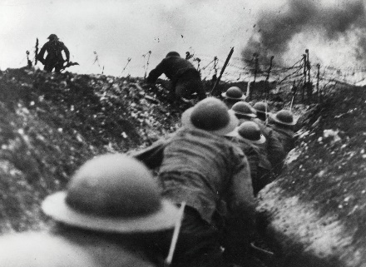
At dawn the Padre had read to them: ‘Thou shalt not be afraid for the terror by night; nor for the arrow that flieth by day…A thousand shall fall at thy side, and ten thousand at thy right hand; but it shall not come nigh thee’ (Psalm 91:5&7).
Irish soldiers played a major part at the Somme and their involvement would have repercussions for Ireland long after the initial fighting of the battle. The 36th (Ulster) Division was committed in the attack on the first day, tasked with taking a German fortification called the Schwaben Redoubt.
They were among the few units to reach their objective, but reinforcements despatched into the carnage of no man's land never reached them, and eventually, isolated and surrounded they were forced to withdraw.
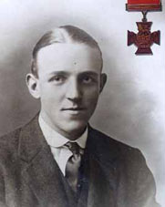
The 36th (Ulster) Division was relieved on 2nd July having suffered more than 5,000 casualties - 2,069 of whom were killed. Of the nine Victoria Crosses awarded on the day, three went to the Ulster Division - two of them posthumously, one of them being to Private William McFadzean (Photo), a Presbyterian, who the night before the Somme attack died as he threw himself on a box of grenades saving others.
Presbyterians stepped up to the call to defend their nation, they served with distinction and gallantry from the manse, the farm, the village, the towns and cities, the length and breadth of our island. The Moderator at the time the Right Rev. Professor Thomas Hamill, D.D. wrote in a letter to congregations; ‘As we all know, there is a widespread and rapidly growing
desire that in this great crisis of our country’s history every man and woman should hear the call, and be afforded opportunity to take share in National Service, and so hasten the day of victory.’
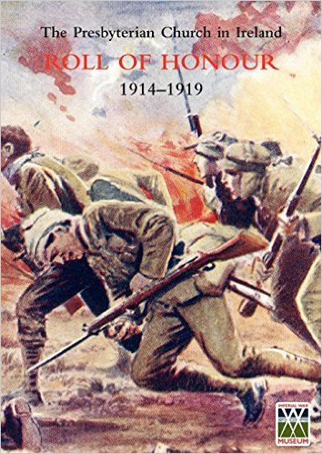
Their names were immortalised soon after the War in a monumental work carried out by the Presbyterian Historical Society entitled, ‘The Presbyterian Church in Ireland Roll of Honour, 1914-1919’.
This carefully researched roll contains upwards of 24,000 names but it is incomplete with an estimated 2,000 names missing because some congregations did not make returns, others were late and there were many Presbyterian young men not actively identified with church life whose names did not find their way to the list. The book also contains a Manse Roll of Honour of Minsters and the sons and daughters of Ministers who served.
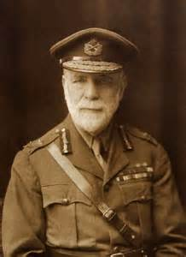
The Presbyterian Church in Ireland gave spiritual leadership to those who served through the ministry of its Chaplains, led by Right Rev. Major-General Dr. John M. Simms, C.B., C.M.G., D.D., K.H.C., who was Principal Chaplain to the Expeditionary Force. Simms was described by one of his Chaplains as ‘a man of rare sagacity and wide experience, who for over 30 years has shared the fortunes of our Army in many a campaign…Under Dr Simm’s administration this department has grown from a strength of fifty-four to over six hundred.’
Some 41 Ministers of the Presbyterian Church served as Commissioned Army Chaplains, many of whose service was acknowledged with awards for bravery, including the Rev. James Gilbert Paton, who was awarded the Military Cross with two bars. A good number of Ministers also served with the YMCA; while others enlisted within the ranks of the Army.

Service was not without cost, with three of our Ministers, that we know of, and one of our missionaries, making the ultimate sacrifice. Rev. Alexander Stuart (Photo) of Bessbrook died as a Commissioned Chaplain two weeks after arriving at the front. Rev. William Wilson of Coleraine, serving with the YMCA, died as a result of a motor accident in France. Rev. James Rentoul of Rostrevor died from shell fire in France serving as a Private Soldier with the Royal Army Medical Corps (RAMC). Dr. Neil Gavin was a PCI medical missionary in India who died serving with the RAMC at the front.
At the end of World War One, in the ‘Blue Book’ of 1918 the Committee of Assembly on Ministers and War Work reported ‘that their first word must be one of thankfulness to Almighty God for the victory of arms, and for the recovered blessing of peace. They also recognise that under God blessing is due to the courage and devotion and sacrifices of the men among whom and for whom they work. The Church has nobly supported the committee and we Presbyterians of Ireland have no reason to feel ashamed of the part they played in the greatest of wars.’
After the war was over, PCI reports within the ‘Blue Book’ recognised ‘after the war problems’, such as integrating men who enlisted back into society and church. Unemployment, abuse of alcohol, and demands on the funds of the Orphan Society were also noted. Post-Traumatic Stress was not a diagnosis back then but the symptoms were being identified and discussed by the Presbyterian Church in Ireland.
In a practical way of helping the ‘post-war’ situation, it was decided to erect as a memorial to those who had fallen The Presbyterian War Memorial Hostel, at the corner of Howard Street and Brunswick Street which was completed in 1925. Its purpose was ‘to provide a Memorial to perpetuate the memory of the deeds and sacrifices of the sons and daughters of the Church in the cause of truth and freedom in the Great European War 1914-1918’ and provided accommodation for young people at work or attending university. This tradition is still continued by our Church through Derryvolgie Halls of Residence at Queen’s University, Belfast.

