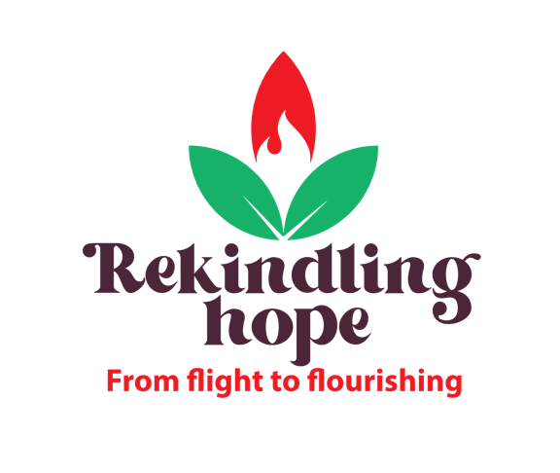

World Development Appeal 2022
Powerpoint script

SLIDE 1 – LOGO
The annual World Development Appeal of the Presbyterian Church in Ireland offers congregations the opportunity to learn more about and to support the valuable and vital work of sustainable development undertaken by our development partners, Christian Aid and Tearfund. Focusing on a particular project gives congregations the opportunity to ‘go deep’ in understanding some of the challenges of sustainable development in a particular location and to see how the partner agency, working with communities there, is seeking to address them.
It also seeks to enable congregations to ‘go wide’ in their understanding of sustainable development by presenting an informed picture of practices that seek to build, within communities, the capacity for a shared vision of the future that is not dictated by context, culture, or circumstances.
SLIDE 2 – INTRODUCTION TO THE 2022 APPEAL
At the end of 2021, the UNHCR reported that almost 90 million people worldwide had been forcibly displaced from their homes. 72 % of these people are hosted in neighbouring countries.
This year’s Appeal focuses on people who have been forced to flee, who have ended up far from home, and on the communities that have welcomed them.
SLIDE 3 – MAP AND FLAG
27% of internationally displaced people came from Syria in 2021 and many of these people have arrived in neighbouring Lebanon, a country that is far from free of its own issues.
The World Bank has described the economic crisis in Lebanon as one of the worst in the world since the 19th century. Inflation is soaring and the crisis has led to regular riots. On top of this, Covid and the 2020 explosion in the port of Beirut have plunged the country into a desperate state. It is into this context that refugees are arriving.
SLIDE 4 – INTRO TO COMMUNITY
The project, supported by Tearfund, that the World Development Appeal is focussing on this year is set in a suburb of Beirut that is home to refugees living alongside undocumented Lebanese people. These groups are marginalised, having little to no access to services like healthcare and education. They live in run down, cramped houses that are full of hazards.
SLIDE 5 – TAHADDI CENTRE
In the heart of this suburb is the Tahaddi Centre. Tahaddi means ‘challenge’ in Arabic and the centre is challenging poverty and hardship, providing holistic care to families who may otherwise have no access to it.
SLIDE 6 – EDUCATION
The Centre provides non-formal education to children who may have missed years of schooling. Lebanese and Syrian children learn together and the centre is one of the few places in Lebanon where this happens. There are also ‘Positive Parenting’ sessions, so the life of the whole family is impacted when the children learn.
SLIDE 7 – SPEECH THERAPY
The Centre also provides healthcare and psychosocial support through a multidisciplinary team. This includes both primary healthcare and treatments such as speech therapy.
SLIDE 8 – SEWING ATELIER
The Centre works with the whole family. In the sewing atelier, women are trained and provided with opportunities to generate their own income as they make products to sell.
SLIDE 9 – IMPACT OF THE CENTRE
The Tahaddi Centre and its dedicated staff are a lighthouse in a dark place, bringing a haven of hope to a community that has little. They embody the ministry of Christ, responding to the needs of the people who have few other places to turn.
SLIDE 10 – INTRO TO SOUTH SUDAN
The World Development Appeal will also support Christian Aid projects in South Sudan. Following the outbreak of violence in 2013, one in every three people in South Sudan is an Internally Displaced Person. The huge movement of people around the country, with already existing tribal tensions has led to conflict.
SLIDE 11 – PROJECT IN SOUTH SUDAN
The Church’s ability to speak into these situations of conflict is unique and the South Sudan Council of Churches is working at community level to bring reconciliation across South Sudan. One of the programmes has involved using the ‘cineboda’, a solar-powered cinema on a motorbike, used to broadcast messages of peace and reconciliation in hard to reach areas, which can be significant locations of conflict. After a screening, a facilitator encourages dialogue. Participants can also record their own messages of peace, which can be used to communicate across divides. “With the motorbike cinema we took the voice of the Heads of Churches to people who would otherwise never be reached – more than 30 remote locations – people who were fighting each other heard the teachings on peace and forgiveness directly and it made us have serious discussions in our communities.” Longar Sog, Cineboda Team Leader and Pastor, Episcopal Church of South Sudan.
SLIDE 12 – PRAYER POINTS
Pray for the World Development Appeal and the parts of the world that it seeks to support.
SLIDE 13 – THANK YOU
Thank you for your support of this year’s World Development Appeal.

