Empowering Vulnerable
Communities in Bangladesh

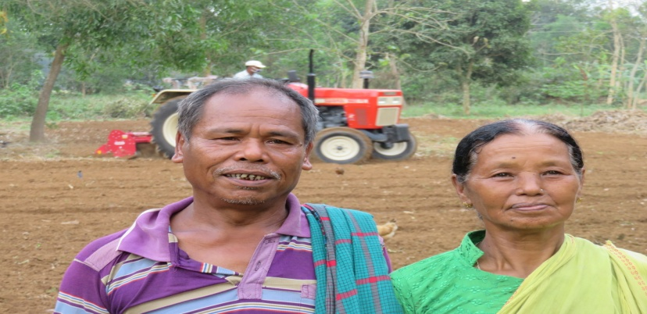
Christian Aid works in Bangladesh to help improve the lives of the most vulnerable people in that society. Like many other places, poor people in Bangladesh are often discriminated against. However, in that country, women and girls from poor communities are further marginalised and often exposed to a great degree of violence because of their gender. Gender is not the only factor that contributes to discrimination: other members of poor communities can face further oppression due to their race, nationality, caste, ethnicity, religion or sexual orientation or a combination of these identities.

Since 1989, Christian Aid has been working with a partner organisation called the Christian Commission for Development in Bangladesh (CCDB), which is the development wing of the National Council of Churches in Bangladesh. The CCDB’s program is helping over 50,000 people – 80% of whom are women – to empower them to learn more about their rights, speak up for their entitlements, and to help them to earn a living through farming and other income-generating activities.

This project, supported by the 2019 World Development Appeal, will aim to improve the quality of life of 500 disadvantaged and marginalised households in the Gopalganj and Mymensingh districts of Bangladesh. It will do so by improving economic opportunities for communities through the production of cassava and poultry farming. These households will be selected from vulnerable groups such as small farmers, landless labourers, women, minority groups and tribal people. 60% of the beneficiaries will be female headed households and 5% will be people with disabilities.

The project will benefit people such as Catherina Chambugong (pictured above her husband, Alan Hagidok). She is a 52-year-old mother and grandmother and was supported by the CCDB to grow cassava on her land. Catherina has been a member of a local cooperative and been involved with the CCDB’s poverty reduction program for over 10 years. She is an active member of a group saving scheme which has allowed her to grow her savings and to benefit from loans to help build her farm. In the past, she used half of her land to cultivate turmeric pods and pineapples. The other half of her land, which lay on higher ground, remained unused. Unfortunately, excessive rainfall led to her turmeric and pineapple crops being destroyed and she was unable to get any financial return on the investment she had made by selling valuables and taking out a loan.

However, through the CCDB, Catherina learnt about the opportunities provided by a local company called PRAN which would support her in growing cassava and who would then buy her crops at a fair price. It is easy to grow cassava as it requires less inputs in terms of labour, water and pesticides. Cassava grows on higher land and it was therefore particularly suitable for cultivation on Catherina’s land. After receiving an interest free loan of 10,000 BDT, she produced over 6,000kg of cassava which was then purchased by PRAN, at a profit of almost 30,000 BDT.

Catherina’s family are now more financially secure, and she has decided to invest further in the production of this sustainable, low-risk crop. Catherina and her husband have been empowered to make important decisions for their family and to make choices about their livelihoods and wellbeing that they would not have had before. As well as being trained on the technical and business skills required to sustain their own farm, the project has also helped Catherina to build awareness of the rights and entitlements of people in her community which will help them to overcome inequalities and injustices within their society.

By supporting the World Development Appeal in 2019, you can help to change the lives of many people like Catherina and her family – regardless of their identity – to help them to improve their livelihoods, to empower them to stand up for their rights and entitlements, and to have a greater voice in society.

