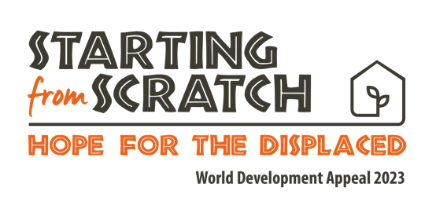

Palm Oil
Information sheet

Protecting people and the planet

Did you know that people are being forced off their land to meet the global demand for palm oil?
In countries like Sierra Leone, Honduras and Guatemala, thousands of people are forced to flee their homes and communities to make way for large palm oil plantations.
The creation of these plantations leaves thousands of people displaced and without a community every year. Those who resist often find themselves imprisoned, beaten or even killed for standing up for their rights to live on their traditional lands.
The palm oil industry is huge, with around half of all supermarket products containing some trace of palm oil, including some you might not expect!...
- Cakes
- Biscuits
- Chocolate
- Detergents
- Cosmetics such as shampoo
- Toothpaste
As well as abusing people, the palm oil industry is responsible for destroying ecologically important tropical landscapes across Africa, Asia and Central America.
We know that deforestation accelerates climate change, which hurts both people, animals and our planet. Leaving those who rely on the forest for survival incredibly vulnerable.
So, what can we do?
Well, as consumers we’re powerful!
- Can you check the products in your home? Are there any you can change for something else the next time you shop?
- Can you tell someone about this? Educate your friends and family about the impact of palm oil.
- Can you look for items that are labelled as ‘sustainably sourced palm oil’ and purchase those instead?
- Next time you’re making a considered purchase, could you research the product on any of the following guides?
- The Good Shopping Guide – Home - The Good Shopping Guide
- Goodonyou.eco
- Ethical Consumer: the alternative consumer organisation
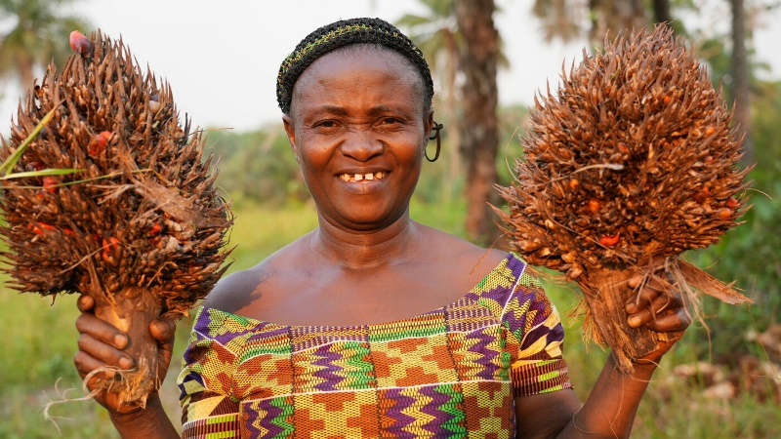
Photographed: Katumu Canfeh, posing with the kernel plants. The plants are widely used to produce palm oil. Credit: Christian Aid/ Jonathan Y Bundu.

