For reflection and discussion

‘Often as individuals and churches we have failed to show God’s love and grace…’

Q. Where do we most feel our failures to show Gods love and grace as Christian peacebuilders?

ACCORDINGLY, WE AFFIRM Christian peacebuilding
to be part of Christian discipleship
and reassert the Church’s calling
to pursue a peaceful and just society in our day

For reflection and discussion

‘Sometimes the local church should be more courageous about speaking out…’

Q. What issues of peace or justice should your local church be speaking out about?

WE SEEK a more reconciled community
at peace with each other,
where friend and foe,
working together for the common good,
can experience healing
and the grace of our Lord Jesus Christ.

For reflection and discussion

‘We have to turn our eyes outward… there are so many needs in our community’

Q. How could a wider vision for society become a greater part of your individual and congregational witness as followers of Jesus?

Additional Vision for Society materials are available at:
https://www.presbyterianireland.org/visionforsociety
4

VISION FOR SOCIETY

LIVING OUT A VERSION OF THE VISION

The 2016 General Assembly welcomed and adopted the Vision for Society Statement, which seeks to continue to place peacebuilding firmly at the heart of Christian discipleship and the Presbyterian Church in Ireland.

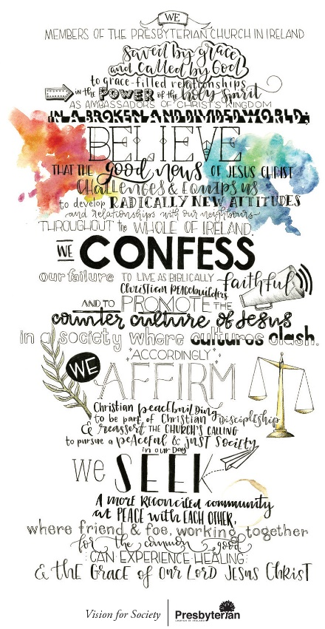
There are still deep-rooted problems in our society and many fault-lines. Into this situation the Church of Jesus Christ is to be a voice of hope. However, if that hope is to be real, we as congregations and members of the Presbyterian Church in Ireland must find ways of living out a version of this vision in our communities and day to day interactions with others. That version will look different from place to place and life to life, depending on our particular challenges and opportunities, But God calls us to rise to those challenges and take those opportunities.

1
A VISION ROOTED IN JESUS’ CALL TO FOLLOW HIM

Read Matthew 5v.13-16.

For discussion
Q. How do Jesus’ images of His people as salt and light challenge our tendency to avoid getting involved in the day-to-day friction and fractures in our community life?

Read Romans 12v.9-21

For discussion
Q. How does the mention of values such as ‘love’, ‘sincerity’, ‘zeal’, ‘joyful hope’, patience in affliction’, ‘sharing’, ‘hospitality’, blessing’, ‘living at peace with others’, ‘not seeking revenge’, ‘overcoming evil with good’ help us gain a vision for what Christian peace building look like in practice?

A VISION THAT NEEDS TO BE SEEN IN US AS GOD’S PEOPLE

In the DVD clip you are about to watch, Kate Docherty, Clerk of Session in Enniskillen Presbyterian Church, unpacks what living a version of the vision for society looks like for her as a member of the Presbyterian Church in Ireland. The clip features the words of the Vision for Society, section by section, and introduces the questions for discussion that you will turn to after watching as a stimulus to discussion, prayer, action and real change.

Watch the DVD clip

LIVING OUT OUR VERSION OF THE VISION

To help us move from vision to reality, discuss the following questions drawn from the Vision for Society statement and clip you have just watched.

2

WE, MEMBERS OF THE PRESBYTERIAN CHURCH IN IRELAND,
saved by grace
and called by God to grace-filled relationships,
in the power of the Holy Spirit
as ambassadors of Christ’s Kingdom
in a broken and divided world;

For reflection and discussion:

‘Every contact leaves a trace…’

Q. What contacts do you have that are opportunities to leave a trace of the grace of God?

BELIEVE that the Good News of Jesus Christ
challenges and equips us
to develop radically new attitudes and relationships
with our neighbours throughout the whole of Ireland.

For reflection and discussion

‘We have to think about who is our neighbour in this new society…’

Q. Who are the people who are not like us to whom God wants us to stretch ourselves to show His love?

WE CONFESS our failure
to live as Biblically faithful Christian peacebuilders
and to promote the counter culture of Jesus
in a society where cultures clash.

3

