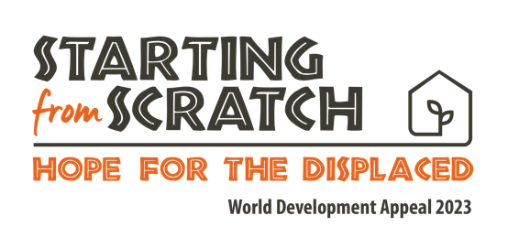

Children’s talk
Moving house

Boys and Girls,

Put your hands up if you have ever had to move house?

Well done, because you have moved to the best place in the country….

What kind of things do you have to do if you are moving house? (Think about packing up boxes, redecorating a new bedroom, looking after pets etc etc)

I wonder how you would feel if I said that you had to move in a few weeks to… (pick a few place names around Northern Ireland/Ireland - some near, some far, some nice, some maybe not so nice - make a judgement on your own location). You might be excited, or a bit nervous, or maybe even down right sad or scared to leave behind friends and family and school and church.

One final time, imagine if I told you you were moving house this afternoon. You had no time to pack - except maybe what you could fit in a schoolbag - and you weren’t too sure where you were going to end up, but almost certainly you’ll finish in a different country - where you don’t speak the language, you can’t go to school, and maybe it isn’t even all that safe. That would be really hard wouldn’t it?

Boys and girls, did you know that right now, over 100 million people across the world have had to pack up like that and leave their homes? They’ve maybe left because of a big disaster like an earthquake or a flood. Maybe there’s been a war and they’ve had to leave in order to stay safe. Maybe there is no rain, so there are no crops and they’ve left in order to make sure they had enough food to eat.

Right throughout the Bible, God makes it really clear that people like us who love and follow him are to be extra concerned about those who are in need - just like people we’re talking about who have had to flee their home. If we are followers of Jesus, he tells us to love our neighbour - and that means both the person living next door and the person in need right across the world - people who are our Global Neighbours.

It’s hard because we can sometimes feel a bit powerless to help in situations like this. And yet, it just doesn’t feel fair, sure it doesn’t. It doesn’t feel right that boys and girls just like you don’t have safe homes to sleep in, safe schools to learn in, safe streets to play in. You’re right, it isn’t fair, and God doesn’t think it is fair either. In the Bible, we read that God is a God who loves when things are fair - when there is Justice. If we belong to Jesus then we need to do something about this.

There are lots of things that your mum and dads can do be to be part of a more Just world, but let me tell you boys and girls what the biggest thing you can do is.

You can PRAY.

Did you know that Prayer can change things? Did you know that when God hears our prayers he acts, and that God can do things that are impossible?

Sometimes when I find it hard to pray for really big things I start by imagining what it must be like to be there, to be in a place where we’ve had to leave our home, and then I ask God to make it better.

So why don’t we do that together now?

