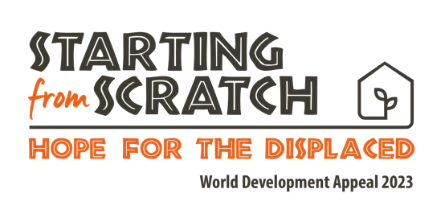

Bangladesh Story – Flood Aid

Around the world, communities face a range of challenges: the cost-of-living crisis, conflict, and climate change are destroying lives and livelihoods. Each is enough to disrupt lives and destroy communities, but for those already living in extreme poverty, the compounding risks are immense.

In Bangladesh, catastrophic flooding can spell disaster for already vulnerable communities. Regular flooding not only brings crop loss, disease, displacement and death, it sets communities back and pushes them further into poverty.

Devastating flooding has been a repeated reality for Salma*, her husband Kamal* and their family. Daily life in Kurigram, the poorest district in Bangladesh, is already hard enough - but having their lives turned upside down at a moment's notice has been almost unbearable.

Like Salma, over two million people who live in this impoverished district are hugely vulnerable when illness or disaster strike. Food and employment are scarce, and anything that disrupts people's ability to get out and work means a loss of income and food scarcity. In addition, when it comes to flooding, the very crops people rely on for food and income are totally destroyed. Tubewells and latrines are also damaged through flood water contamination, resulting in a loss of clean water and rapid spread of waterborne diseases.

Salma and Kamal desperately needed a way to protect their family from these repeated crises, and thanks to support from people like you, they found it.

Tearfund’s partner - the local church - is equipping communities to reduce the impact of disasters through resilient housing, community planning and diversified incomes, meaning communities have room to truly thrive, even in the face of disaster. For families like Salma and Kamal’s, it means they aren’t Starting from Scratch every time a disaster strikes. This journey from crisis to resilience is essential to see lasting transformation; whole communities lifting themselves out of poverty for the long term.

Your gift can help make that happen for more families like Salma and Kamal’s: please donate today.

*names changed

