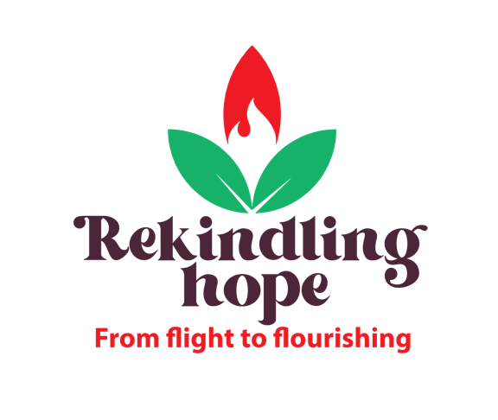

World Development Appeal 2022
Reflections of Scripture

Jeremiah 7:1-11
This passage is a challenge to the people to mend their ways, to come back to full trust in the living God.
It’s a challenge to superficial, self-serving religion and a call to justice, service and a right treatment of society’s vulnerable.
“Reform your ways and your actions!” – that’s Jeremiah’s message greeting those who gather for worship. It’s a stark message, scything through their thoughts as they arrive at the Temple door.
Jeremiah is challenging a complacent faith among those who come to worship. He’s essentially saying that their temple worship is not reflected in their lives. It’s become a ritual; they dot the i’s of temple attendance so that they can live whatever way they like.
Jeremiah is calling them to walk the walk as well as talk the talk. In fact, he’s saying that their walk is inconsistent with their talk. It reveals their true inner status and Jeremiah calls for a change of direction.
After many years under the corrupt regime of King Manasseh, Judah was experiencing a period of reform. Progress had been made – King Josiah’s changes may well provide the backdrop to this passage. Perhaps this phrase “The Temple of the Lord, the Temple of the Lord, the Temple of the Lord” is the slogan of these reforms. Things may have been going in the right direction, but it’s clear that much, much more needed to happen. Rather than heartfelt worship reflected in changed lives, there was superficial spirituality that trusted in a building rather than on God Himself.
Jeremiah’s message applies to us too. It challenges us about substance over superficial, it challenges us to live out our faith in a way that impacts every aspect of who we are; Monday to Saturday as well as Sunday.
Jeremiah is confronting the people and challenging them to change their direction. He’s challenging them to live lives that reflect their faith. As in James 2:17, “faith by itself, if it is not accompanied by action, is dead.”
It’s no coincidence that Jesus quotes Jeremiah when He clears the Temple, because in many ways, what was happening in Jesus day was a mirror image of what was going on in the time of Jeremiah. We see faith that is self-serving, rather than glorifying God. Religious ritual rather than real relationship with their Heavenly Father. This is perhaps best illustrated by the fact that the religious leaders couldn’t recognise Jesus when He came and devised plans for His downfall when He threatened their way of doing religion.
Jesus is the Temple of the Lord. He connects the Temple to Himself. While this clearly points to the sacrificial nature of His death, it also undoubtedly draws our attention to Him as our object of worship. Our worship is the whole of life – personal and public, in word and in action, in truth and in love.
Luke 4:14-30
In Luke 4, Jesus introduces His ministry. This is sometimes called the Nazareth manifesto. We see the extent of Jesus’ ministry as he reads from the scroll of the prophet Isaiah in the synagogue in Nazareth. The centrality of this passage cannot be over-emphasised. It defines who Jesus is and what He has come to do. The good news that Jesus brings has implications for everyone – in Him the poor hear good news, the prisoner and oppressed find release, the blind see and all who are under a yoke receive the declaration of a year of the Lord’s favour.
It’s important to note that Jesus comes in the power of the Spirit. Luke tells us that He returned from His temptations in the wilderness “in the power of the Spirit”. This quote from Isaiah reinforces this: “The Spirit of the Lord is on me, because He has anointed me”. Jesus’ ministry is not just His own strength, significant as that is. It is in the power of the Spirit and the authority of the Trinity. Jesus is God’s Son incarnate. We must never lose sight of that.
Jesus’ mission is always to the whole person. It is not only to the soul that He brings His life-giving transformation. His desire is to bring His healing and restoration to every part of us. We should never underestimate the sheer scale of what Jesus came to do.
Jesus came to bring recovery of sight for the blind; both physical and spiritual blindness.
Jesus tells us here that the Gospel is for the poor and oppressed; both socially and spiritually. There is a sense that the poor often recognise their need more than those who are materially well-off, and therefore are more receptive to the Gospel. But Luke also wants us to grasp that the Gospel is particularly good news for those on the margins. He appears to have a particular heart, a compassion for the vulnerable in society. This echoes God’s heart – in the Old Testament, people of God are constantly reminded of their responsibility to the widow, orphan and stranger; those who have no other support structures.
There’s also an emphasis on liberation. The Gospel is liberating. It’s not a set of rules and regulations. Indeed the Good News of God’s grace challenges that. It is free, and about freedom. These verses speak of freedom for prisoners and the oppressed – socially, mentally, and spiritually captive people as well as the physically imprisoned. In Jesus, God wants to set us free to be the people He has created us to be.
Tim Chester, in his book Good News to the Poor writes “The Christian community is both a sign and a promise of God’s liberation. We are the presence of God’s liberating kingdom in a broken world. We are the place where liberation can be found, offering a home for exiled people. We are to welcome the broken people to a community of broken people. We are the community among whom liberation is a present reality – the jubilee people who live with new economic and social relationships. We are the light of the world, a city on a hill.”
We see this idea of liberation in the concept of Jubilee, alluded to in Jesus’ reference to “the year of the Lord’s favour”. In Leviticus 25, God gave the concept of Jubilee to His people. It’s like a great reset button returning everything to the way it was. Families who sold land due to poverty got it back. People who were indentured servants were released from their contracts. Even the land was to be given a rest.
Just as Jubilee offers a new start, so does Jesus. This is one of the great truths of the Gospel. Jesus comes to make things right, to reverse what was wrong. When He died, He made forgiveness possible; so much so that people like Peter – who got it so spectacularly wrong – are reinstated. Paul, who was implicit in the death of Stephen, and in the persecution of the followers of Jesus, has his life turned around. This Gospel is radical.
This year’s World Development Appeal facilitates our connection with a community in Lebanon which faces many challenges. Our giving to the work of the Tahaddi Centre is an act of worship, an outworking of our faith in Jesus Christ, the One who came to transform lives. This is our opportunity to rekindle hope in the lives of those who are living on the margins. To show that we care, and to enable them to flourish as God intended.

