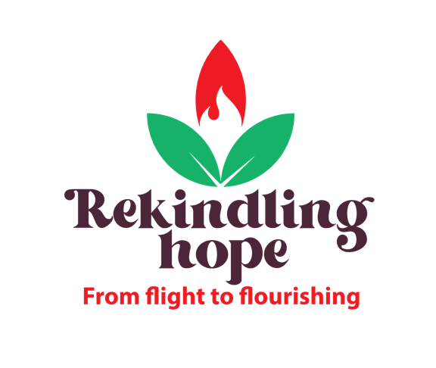

World Development Appeal 2022
Children’s address – Lebanon focus

I wonder boys and girls if you have ever heard the question about the desert island?

If you had to go and live on a desert island, and you could only take 3 things, what would you take with you?

Maybe you’d take something smart like a toothbrush, or matches to make a fire, or tools to build a shelter, or maybe you’d take a book, or your favourite teddy or your Nintendo Switch.

(It’s a fun question, because of course if you bring your Nintendo Switch or something like it, where are you going to plug it in to charge it????)

Today the grown ups in church are going to hear about people in a country called Lebanon, and how as the Presbyterian Church across Ireland we can support people there who in great nee: people who don’t have the important things that we all need: food, shelter, safety, education and work. Just like places right across the world, there are lots of people in Lebanon who have had to flee their home. They haven’t gone to stay on a desert island but have had to leave their home and go somewhere new. Maybe they had to leave because of a war, or maybe because of a famine - where there isn’t enough food to go around - or maybe because there’s been a disaster like a flood or an earthquake. Families just like yours and mine who have had to pick up a few things and leave their home.

I wonder if I asked you the question again - except this time you aren’t going to a desert island. You are leaving your home, you aren’t sure if you’ll ever be back again, and you aren’t really sure where you are going to end up. What would you take then? You might still bring your favourite teddy or your favourite book. Maybe you’d want a coat or extra shoes or a thick blanket.

Can you imagine what that would be like? It’s hard to imagine isn’t it.

Lots of you will have heard about the war in Ukraine. Because of all of that fighting, nearly 5 million children - kids just like you - have had to leave their home in order to stay safe. It’s the same in Lebanon - millions of people fleeing nearby countries in order to find a safe place to live. (Extra info if appropriate: 1.5 million refugees living in Lebanon. This means that in Lebanon nearly 1 in 3 people is a refugee fleeing conflict. Lebanon hosts the most refugees in the world, per capita population and square km.)

Right throughout the Bible, God makes it really clear that people like us who love and follow him are to be extra concerned about those who are in need - just like people we’re talking about who have had to flee their home. If we are followers of Jesus, he tells us to love our neighbour - and that means both the person living next door and the person in need right across the world - people who are our Global Neighbours.

It’s hard because we can sometimes feel a bit powerless to help in situations like this. And yet, it just doesn’t feel fair, sure it doesn’t. It doesn’t feel right. We feel the need to do something.

But let me tell you boys and girls what the biggest thing you can do is.

You can PRAY.

Did you know that Prayer can change things? Did you know that when God hears our prayers he acts, and that God can do things that are impossible?

Sometimes when I find it hard to pray for really big things I start by imagining what it must be like to be there and then I ask God to make it better.

So why don’t we do that together now?

