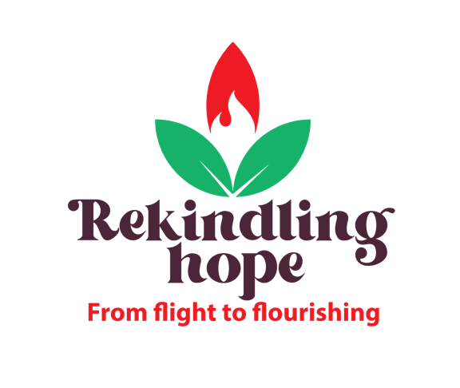
World Development Appeal 2022
Prayer for Lebanon

Lord of all the Earth,

You are the God of the Nations and we worship you as Creator, as Father, and as our Saviour.

We want to pray for the nation of Lebanon.

We pray for those who have fled their home because of conflict - the 1.5 million refugees living in Lebanon. Individuals, families and whole communities who have lost so much. We pray too for those already living in communities where they have settled. Both groups are living with uncertainty, facing real challenges to meet their basic needs each day. We pray that you might meet those needs. Move us, Lord, to be burdened in prayer for these men, women and children who are made in your image and who bear your likeness.

We pray for the nation and the region as a whole. In the midst of economic chaos we pray you might bring stability. In the face of ethnic and racial tensions we pray that you might bring peace. Where there is greed, abuse of power and mistrust, we pray you would bring low the schemes of those who mean evil.

We pray for the church in Lebanon. We know the church is your chosen vessel for transformation. Raise up your church in that place. Raise up organisations like LSESD who seek your Kingdom on their doorstep. Provide vision, resources and favour. Mobilise and equip ordinary Christians to be Kingdom people - people known by their love for one another and for their love for their neighbour. Might they especially be known for their love of those on the margins.

Lebanon is a place with a rich Christian history. And so with the words of Psalm 92 we pray your blessing upon this nation and on your people there.

May the righteous flourish like a palm tree,
may they grow like a cedar of Lebanon;
planted in the house of the Lord,
may they flourish in the courts of our God.

We pray in the name of Jesus.

