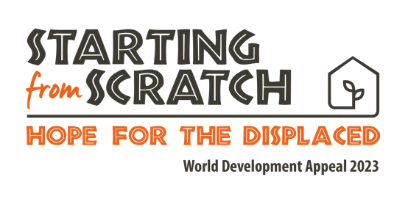

Prayer

Dear Lord,

We acknowledge this day that you are a God who loves Justice - you hate robbery and wrongdoing (Isaiah 61), and so we know that you are grieved at all the injustice that we see, and maybe even experience; the tide of injustice that sweeps across this world. You grieve for those trapped in slavery or inescapable poverty. You grieve for those who have no place to call ‘Home’ - for those pushed off the land by disaster or by human greed and violence. You grieve for those whose future has been robbed - who have a God-given spark of creativity and potential, but who have been crushed and beaten down by poverty and injustice. We grieve too Lord, though perhaps we don’t grieve enough. Holy Spirit, we invite you to be at work in us - shaping us to love Justice as you do.

We pray especially for churches in Sierra Leone, in Bangladesh and in other parts of your world where some of the 108 million people who have been displaced have found themselves. We pray that your people would be people of Hope, people who can provide those who have been displaced with what they need: a place to belong, land to dwell on, purposeful work to be a part of. Thank you that in Christ, your Church has all it needs to offer hope to those who have lost everything. We pray especially for church leaders as they navigate some of the challenges faced within their communities. We pray they and their congregations might understand the commands of God in Leviticus - to welcome the foreigner, knowing that God’s people were foreigners, were displaced people, in Egypt. May the church around the world, and Lord here in Northern Ireland, be known as a place of welcome and of transformation for those who have been forced to leave their home.

Lord, you are the God of the distressed, who promises to lift out of the water and set down in wide-open spaces (Psalm 18:19). You are the God who created, sustains and owns the whole of Creation. Every inch of land belongs to you. For those forced off their land - we cry out to you for Justice. Across the world, Lord, restore the broken relationships that cause so much injustice: between humanity and the land, between humanity and its neighbour and between humanity and its creator. We long for the renewal and resolution of all things in Christ. Show us Lord how we can play our part in that - through the World Development appeal and our generosity, through our ongoing prayers and through our involvement in our local community. Use us Lord. Bring restoration Lord.

In Jesus Name, amen.

