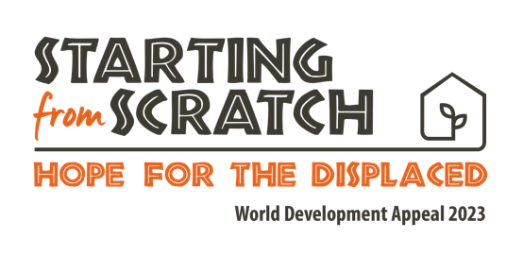

Children’s talk
Journey

Intro activity:

What’s the longest journey you’ve ever made? Donegal? London? Florida?
How long was it?
How did you get there? Planes? Cars?
Did you take anything with you to make the journey easier? Passport? Right clothes? Money? Phone? A magazine? Puzzle book? Switch or tablet?

*Bring a bag or suitcase with things that make journey’s easier in it: Toy car? Phone? Money? Map? Friendship bracelet? (Take the items out and discuss how they help us on a journey)

It can be really exciting to go on a journey, can’t it? Especially if we’re going on a lovely holiday!

Thought:

(Note: Use photograph of Hawa walking)

This is Hawa. She is from Siera Leone, a country in west Africa. She also had to go on a journey. But it wasn’t for a holiday. She had to leave her home because a big company wanted to use her farmland to grow their own plants and they forced her to move out of her home.

Without land Hawa and her family would have no way of growing food to eat, and so she had no choice but to leave and find somewhere new for them to live.

So she travelled to a new place... How do you think she might have felt? Worried, sad, anxious, lonely?

This reminds me of a story from the Bible in the Book of Ruth. It's a story about a woman named Ruth who also went on a journey with her mother-in-law, Naomi. Ruth faced many challenges – there was a famine in the place where they lived, which means there was no food to eat or water to drink. So, they decided to go back to the country where Naomi grew up. But this was a foreign country to Ruth – she didn't know this place she would be going to, or whether people would want her there. Even with her fears, Ruth never gave up hope – she trusted in God that He would look after her. And Ruth even promised to stay with Naomi and take care of her saying:

"Where you go, I will go, and where you stay, I will stay. Your people will be my people, and your God will be my God."

And you know what? God did look after them. God provided Boaz who welcomed Ruth. Boaz provided a place for her to work and collect food, and a safe place for her to stay.

Hawa also found a place to stay, somewhere to grow her food, and she was able to become part of a new community, making new friends, and finding people who would look after her. Christian Aid, one of the charities supported by the Presbyterian Church in Ireland also helped Hawa and other women, by forming groups so they can help each other. They help those groups to save money together so they can buy the things they need and they have been teaching them about the best ways to grow food so that they can get enough to eat.

(Use photos of Hawa tending her crops and also with her kids)

Just like Ruth's journey, Hawa’s journey ended with a new beginning, settling in a new home, with new neighbours and friends.

Conclusion:
God loves all people wherever they live and that includes Hawa from Sierra Leone. That’s why Christian Aid and Tearfund believe that we should help people in need all around the world.

There are lots of ways that we can help those in need. We can all be kind and helpful to others that we meet, especially if they seem sad or lonely. We can also pray for people like Hawa in Sierra Leone - and for charities like Tearfund and Christian Aid as they work to help more people.

Let’s pray for them now.

Close in prayer

