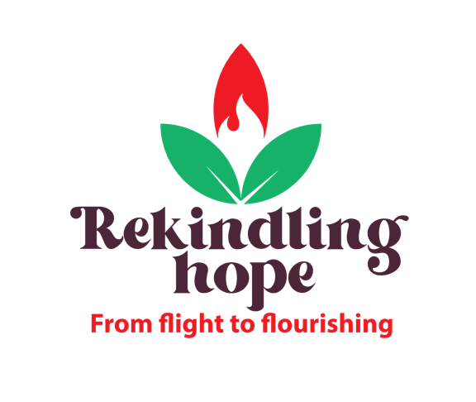

World Development Appeal 2022
Prayer for South Sudan

Gracious and Compassionate Lord,
Slow to anger and abounding in love,
You call us your children when we act as peacemakers,
And so, we pray for the people of South Sudan,
Where deep divisions have so often erupted into violence.
We pray that you would heal divisions and bring lasting peace.
Bless those peacemakers who are courageously leading the way,
Such as the South Sudan Council of Churches.
May their efforts to encourage dialogue build understanding,
So, that enemies and rivals may become sisters and brothers,
Rekindle hope in South Sudan,
That communities may know peace and security that would allow them to flourish,
In the name of Jesus, the prince of peace, we pray.
Amen.

